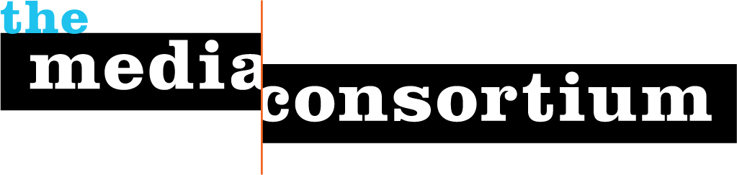

Sponsor Opportunities for
Support Your Media Day
Organized by The Media Consortium

Who: The Media Consortium is a national non-profit network of independent media organizations including Mother Jones, Free Speech TV, The Nation Institute, Colorlines.com, YES! Magazine, The UpTake, The Young Turks, and The Laura Flanders Show. We are the media for the 99%, telling the stories the mainstream, corporate media do not dare to tell. Collectively, our content reaches over 100 million Americans per month.

What: On Feb. 15, 2012, over 30 Media Consortium member outlets will participate in a collaborative, one-day fundraiser: Support Your Media Day. Each participating outlet will work together in friendly competition to accrue the most donations for the chance to win a variety of prizes and matching grants. Outlets will drive their audience to contribute through a portal website, which will prominently feature the logos of our sponsor organizations as well as a live video feed that can also be imbedded on the home pages of all participating groups. Featuring progressive luminaries like Cenk Uygur, Laura Flanders, Chris Rabb, and others, this feed will offer an entertaining overview of the impact and importance of this sector in an election year.

How: It’s easy to join Support Your Media Day. We are looking for sponsors to help underwrite the costs of the fundraiser, underwrite branded prizes and incentives for media organizations, and sponsor the live stream that will accompany the fundraiser. Your products and services will be viewed by an engaged audience of over 2.2 million educated, engaged, committed progressive donors who will experience your brand as a supporter of the media they depend on.

Platinum Sponsorship: $10,000
- Prize branded to your organization to be auctioned off during the day
- Once-per-hour pre-recorded 30-second video commercial
- “Billboard” at the beginning and end of coverage segments that contains company logo and a 10-second message.
- Logo on Support Your Media Day website
- Text advertisement on Support Your Media Day blog and social media promotion.
- Up to 3 sponsorships available

Gold Sponsorship: $5,000
- Once-per-hour pre-recorded 30-second video commercial
- “Billboard” at the beginning and end of coverage segments that contains company logo and a 10-second message.
- Logo on Support Your Media Day website
- Social Media Promotion
- Up to 5 sponsorships available

Silver Sponsorship: $2,500
- “Billboard” at the beginning and end of coverage segments with company logo
- Logo on Support Your Media Day website
- Social Media Promotion
- Up to 5 sponsorships available

Matching Prizes: $250 value and up
Help us create the prize! Every dollar in matching grants yields $10 in donations!
- Logo on Support Your Media Day website
- Social Media Promotion
- In-Kind Donations OK
- Up to 20 sponsorships available

Contact us! For more information or to claim a sponsorship, contact Jo Ellen Green Kaiser, joellen@themediaconsortium.com, 415.878.3862.

