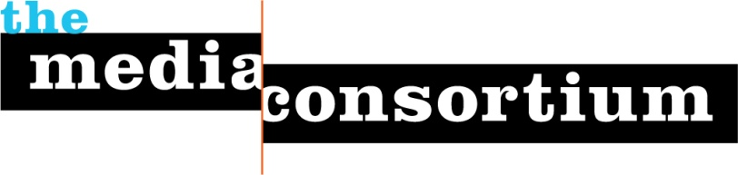

Support Independent Media!
Sponsor TMC’s One-Day, Live-Streamed, Community-Engaging, Collaborative Fundraiser

Why Sponsor Independent Media?
As a triple bottom line company, you believe that a democracy requires engaged, well-informed citizens. Informing, educating and engaging the public is the role of the independent media. The public turns to independent media to learn about the ecological dangers of hydrofracking; about the high social cost of low wages; and about the role media consolidation plays in increasing the digital divide. When it comes to creating a more just society, our vision and yours are aligned.

Why Sponsor the Media Consortium’s Collaborative Fundraiser?
There’s no easier way to support independent media than by sponsoring our collaborative fundraiser. This one-day, live, online and TV-hosted video-streamed event will bring together the best and brightest talents in the independent media world to interview each other, highlight major stories, discuss news of the day, and interact with their collective communities via twitter, Facebook, and other social media. An expected combined audience of over 20 million users, coming from 30 participating independent media outlets, will be directed to a special fundraiser website, where they will be asked to join in a friendly competition to raise the most money for their favorite media organization.

As a sponsor, your company will be exposed to this large, engaged audience. Sponsorship of this collaborative fundraiser will:

- Increase your visibility before a national audience of thousands of engaged, active, and loyal users;
- Enhance your corporate image by supporting the entire sector of the independent media;
- Break through to a new audience via an event that will make use of the latest tools in social media and web streaming.

Who is the Media Consortium?
The Media Consortium, www.themediaconsortium.org, is a national network of over 50 independent Our members, including websites, print magazines, television networks, radio and film producers. Our mission is to support and grow an independent media sector; our vision is for our sector to become an agenda-setter for national conversation.

Yes, I want to Learn More--Whom Do I Contact?
Please contact Jo Ellen Green Kaiser at joellen@themediaconsortium.com or 415-878-3862 to learn more about sponsorship opportunities.

