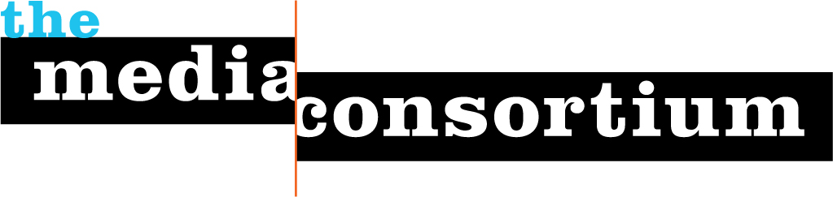

Internal Digital Refresh Workshop:
Strategic Retreat Agenda

Prep work
- Need to share digital survey results with org 3 days b4 mtng
- Need to have copies of digital survey.
- Will we have typed up analysis from Golis for mtng participants?
- Copies of The Big Thaw?

Day 1

10-10:15 Project/Retreat Goals and Agenda-TVS
TVS: Welcome. We’re so excited to be here for the next day and a half.
(Need to do round of intros?) Just as a little background on what brings all here-The idea for the Digital Refresh workshop is part of a larger program called our Incubation and Innovation Lab. Last year, we produced a groundbreaking report called, “The Big Thaw” that identified many of the technological and strategic shifts that independent media must be aware of and figure out how to incorporate in the near and distant future. With the incredible information compiled in this report, we didn’t want to sit around discussing it for years, we wanted members to be able to access and implement these ideas in strategic, supportive space that actually result in experimentation and evolution for the organization.

Our goals:
To review out goals: the Digital Refresh Workshop’s goals for the organization and the strategic retreat weekend.
TMC Goals:
Work w/your organization to revamp and refine your overarching digital strategy.
Identify your current and future target audiences for best strategy in journalism, community building and revenue generation mo
dels.
Develop one experiment or advancement based on digital strategy identified out of strategic retreat. TMC will provide consulting/support for 3 months on that experiment for three months.

10:15-10:30: State of the Media-TVS+AG
A quick trip through the changing media landscape, how journalism organizations are evolving, future trends to look out for and the implications for your organization.
Need to pull together: Big Thaw, Landscape Analysis, Stats (AG help with stats?)
While we may all understand the media world is changing

10:30-11 An Analysis of your Digital Profile-AG
Questions for org:
What did you learn when filling out digital profile?
Did any questions in the digital profile survey spark ideas for you?
Any surprises when your review digital profile or listening to summary of profile?
(Provide copies of digital profile for participants)

AG provide top line synopsis of digital profile
*basic facts
* top traffic drivers
*where traffic is coming from

10:45-11 Break

11-11:45 Understanding your four audiences-AG
Andrew Golis will lead participants through xxxx [fill out quick description) of session.
WHAT’S A GOOD NAME FOR THE SESSION
DO YOU WANT 45 MIN. OR AN HOUR

11:45-12:30 Reviewing and Evaluating Your Goals
How does your organization want to evolve? Participants and workshop leaders will work with the organization to define or refine the organization’s overarching, big picture digital goals.

TAP: review goals from one sheet
Have you had any aha moments from today that adds to, refines, or eradicates your current goals?
Why or why not?

12:30-1:30 Lunch
(Continue goals conversation if necessary)

1:30-2:30 Integrating Audiences and Goals
Using the four audiences and established goals as a baseline, participants and workshop leaders will brainstorm the implications and digital opportunities for the organization’s future editorial, engagement and business models.

2:30-2:45 Break

2:45-3:30 Identifying topline opportunities: Digital Next Steps
After the brainstorm process, participants will narrow down to three ideas/areas they would like to prioritize and explore during the second day.

3:30-3:45 Set up next day/End

Day 2

10-10:10 Recap of Day 1

EBP: I THINK WE MIGHT ALSO WANT TO ENCOURAGE PEOPLE TO SHARE SOME “AHA!” MOMENTS—WHAT REALLY GOT THEM THINKING FROM THE DAY BEFORE?

10:10-10:45 Pick your project!
Based on the three areas/ideas that your organization would like to pursue, participants will identify one area that your organization would like to explore/experiment with over three months with support of TMC workshop leaders.

10:45-12 Digital Refresh Workshop Project: Iterating the 3 month goals, needs and next steps
Participants and TMC workshop leaders will identify the goals, next steps for helping move forward on a major digital project.

