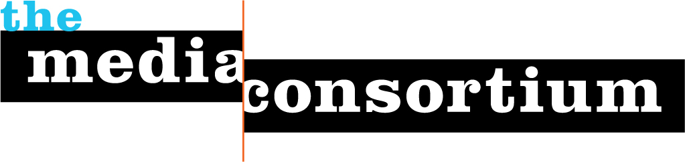

Digital Refresh Workshop:
Strategic Retreat Agenda

MAKE ADJUSTMENTS: 12:30-1:30: lunch and mobile call

Day 1

10-10:15 Project/Retreat Goals and Agenda-TVS
TMC Workshop leaders will review the Digital Refresh Workshop’s goals for the organization and the strategic retreat weekend.

TMC Goals:
- Work w/your organization to revamp and refine your overarching digital strategy.
- Identify your current and future target audiences for best strategy in journalism, community building and revenue generation models.
- Develop one experiment or advancement based on digital strategy identified out of strategic retreat. TMC will provide consulting/support for 3 months on that experiment for three months.

10:15-10:30: State of the Media
TMC strategic workshop leaders will lead participants on a quick trip through the changing media landscape, how journalism organizations are evolving, future trends to look out for and the implications for your organization.
10:30-11 An Analysis of your Digital Profile
In this session, we will discuss your organization’s reaction to the Digital Refresh survey. Participants should review the results from their digital profile survey and analytics before the meeting and be prepared to share their own reactions to the information.

Andrew Golis will then lead participants through an analysis of the organization’s digital profile survey and analytics.

11-11:15 Break

11:15-12 Understanding your four audiences
Andrew will lead participants through a presentation and conversation on how they can understand editorial and business products for the multiple audiences on the web and how they can move their audiences to deeper engagement for broader impact and revenue generation.

12-12:45 Lunch

12:45-1:15 Establishing your core audiences
Using the audience model presented by Andrew, participants will discuss and iterate their top core current audiences and the audiences they want to expand into in the future. They will discuss why these audiences are critical to the organization’s future and the implications on the organizations’ journalism and business models.

1:15-1:45 Matching your goals to the audience model
Participants will work to refine the organization’s current digital goals and identify potential new goals based on their established current/future audiences. At the end of this session, the group will decide on the 1-2 goals that will be the basis for experiment/project brainstorming.

1:45-2 Break

2:00-3:30 Brainstorming digital experiments
Open the brainstorming and creativity doors! Using the information, ideas, and goals developed throughout the day, participants will brainstorm top line ideas and/or areas for digital experimentation that they would like to explore during the next three months. In the last 20 minutes of the session, they will identify the top three ideas and experiments that they want to iterate out during Day 2.

3:30-4:10 Set up next day/End

Day 2

9:30-9:40 Review of Day 1

9:40-10:45 Iterating the three project ideas
Participants will iterate out the top three experiments/ideas established in Day 1, including: experiment/exploration goals, project description and research/resource needs.

10:45-11:15 Identifying the Digital Refresh Workshop Experiment
Once these three ideas are established, participants and TMW workshop leaders will identify the one project that your organization would like to explore/experiment with over three months with the support of TMC workshop leaders.

11-12 Digital Refresh Workshop Project: Next Steps and wrap up
Participants and TMC workshop leaders will identify the three-month timeline, needs and next steps for the organization and TMW’s support role. They will also set up a monthly call

