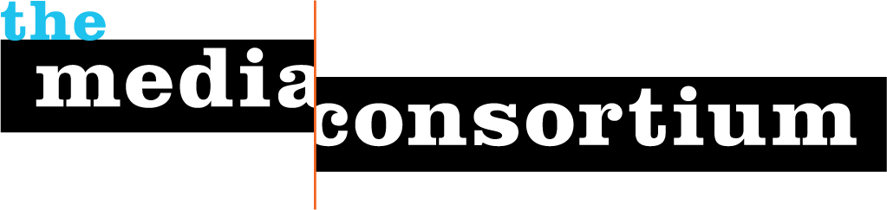
Digital Refresh Workshop Application
The Media Consortium 2010

DIGITAL REFRESH WORKSHOP APPLICATION
Your organization must be a dues paying member of The Media Consortium to qualify for consideration.
Application Deadline: Return form to Tracy Van Slyke at tracy@themediaconsortium.com no later than March 10. If you have questions about the program or application form, please don’t hesitate to contact Tracy or Erin Polgreen at erin@themediaconsortium.com. We will announce the three organizations that will kick off the Digital Refresh Workshop program by March 22.
Name: Phoebe Connelly
Title: Web Editor
Contact Information (email/phone): pconnelly@prospect.org/202.776.0730 x116
1. It’s important that the people and organizations involved in this project are excited and ready to commit to developing a new digital operational strategy. This project will require 5-10 hours of editorial/publishing staff time a month (for three months) in addition to preparation time and participation in the two-day strategic workshop. Please list key members of your editorial/publishing staff that will be able to commit to the Digital Refresh Workshop.
Phoebe Connelly, web editor
Richard Boriskin, business manager
2. Briefly tell us why your organization wants to participate in the Digital Refresh Workshop. (500 words or less)
The American Prospect has always considered the web a key part of our editorial product. It has now been four years since our last full redesign, and we are gearing up for an overhaul of the site. The Digital Refresh Workshop will provide structured guidance on content, tools, and approaches we should consider as we undertake the redesign.
We're seeking guidance on choosing a scalable platform that will allow us to update the site in the future on a regular basis without the need for a complete overhaul. We're also curious about the pros and cons of various display options for our home and article pages given our existing editorial staff and a desire to maximize stickiness and traffic. We currently do not have any in-house technology staff, but have plans to hire someone in the next year--we could also use advice about that.
Finally, we're hoping the workshop will provide contacts with other web editors and designers that we can work collaboratively with or turn to with questions as they arise in the future.

3. Tell us where you think your organizations currently stands in terms of digital operations and where it should be in 2012. (300 words or less)
We have fantastic content, and a dedicated staff that is willing to take on new projects, and cobble together cheap, working tools. However, we're currently hamstrung by a restrictive CMS that is difficult to modify, and lacks the meta-data and URL construction that would allow us to be fully indexed and searchable.
By 2012, we will ideally have been through a complete redesign and have a full time staff member devoted to developing and refining our tech. We should be producing weekly video content. All of our content should be fully indexed, with the ability to display as "related" on any discrete piece. We should have a commenting system that is easily upgraded to incorporate the latest in spam filtering tech. We also hope to be producing a digital edition of the print magazine and be mobile-friendly.
Digital Refresh Workshop Application-page 2
In order to understand your organization’s needs, we need you to submit a digital snapshot. (This information will be kept private.) Please fill in the following:
4. What platforms are you currently active on? Put an X next to all that apply and please note the relative size of your audience on each:

- Print __X___ 40,000
- Online ___X__
- Mobile web _____
- iPhone (or other) mobile app _____
- Text messaging _____
- Television _____
- Online video __X___
- Facebook __X___ 700 fans
- YouTube __X___ weekly video, 29 channel subscribers
- Twitter _X____ 2,000 followers [Note: Staff writers have individual Twitter accounts Adam Serwer: 3,000 Tim Fernholz: 700 Monica Potts: 150 Ann Friedman: 1,500 Alexandra Gutierrez: 350]
- Other (please note):

5. What platforms are you hoping to integrate by 2011? Mark an X to all that apply.
- Print _____
- Online _____
- Mobile web __X___
- iPhone (other) mobile app __X___
- Text messaging _____
- Television _____
- Online video __X___ (increase volume)
- Facebook _____
- YouTube _____
- Twitter _____
- Other (please note):

6. Please fill in:
Average monthly unique visits __ 308,000____
Current size of your e-newsletter list __9,000____
7. Do you accept advertising? (Please note if you accept advertising in print, online, and/or phone).
We currently accept print and online advertising.

Digital Refresh Workshop Application-page 3

8. What is your annual overall budget? What is your annual budget for digital strategies/development?
Our annual overall budget is $3,000,000. Our 2010/2011 budget for digital strategies/development is $150,000. That number assumes a full redesign--we have not previously had a set annual budget for digital development. Setting a realistic number for our annual budget is one of the pieces we'd like to explore as part of the workshop.

9. How large is your staff? Please note if any staff members multitask across positions.
- How many work in editorial? 14 Total
5 editors (3 primarily print, 2 primarily web)
2 at-large editors (no web editing duties)
1 writer/editor (editing duties primarily web)
1 art director
1 editorial assistant
1 copy editor
2 staff writers
- In publishing? 3 Total
1 publisher
1 business manager
1 IT director
- Do you have a staff person dedicated to advertising?
We have two contract ad salespeople
- In outreach/communications/marketing?
Our editorial assistant handles outreach and marketing
- In technology?
We do not currently have any tech staff
10. Do you have any major plans to innovate/expand platforms for 2010/11? Please explain.
We hope to hire a full time web master in 2010 and do a complete redesign of the site.
11. Anything else you want to add?
The Digital Refresh Workshop will give us a needed guidance about best practices as we approach our redesign. We're looking forward to working with the Media Consortium as we confront this next digital challenge!

