**Measuring Impact**

**A Media Consortium Report 2016**

One key aim of journalism is to educate the public about specific instances of corruption, social injustice, and institutional inequity --and possible solutions to the same. The goal of such journalism is that the public will be influenced by these stories to create a more just society. That movement, from reporting to influence to action, is how we define impact.

How can we produce the influence we seek on a consistent basis? That’s the question the Media Consortium has set out to answer, beginning in 2012.

Theory. We started with the belief that to produce influence we would first need to be able to measure influence. Because journalism had not yet developed sophisticated tools to measure influence, we had to build a tool—and the infrastucture to test and to use it.

For a tool, we chose sentiment analysis[[1]](#footnote-1). Working closely with Professor Gary King, the Albert Weatherhead III Professor and Director of the Institute of Quantitative Social Science at Harvard, we decided to measure whether particular instances of journalism moved the public and other media to change the way they talk about a particular issue.

For example, after a story profiling undocumented immigrants living in detention camps, will more people become sympathetic to undocumented immigrants? King’s method uses Twitter as the source of data on sentiment. Looking at the entire Twitter firehose, King and his team can analyze all tweets before and after a story comes out, looking to see if sentiment on the deportation of immigrants changes in a statistically meaningful way. This method goes beyond looking at hashtags and actually uses machine + human learning to analyze the content of the tweets as either pro immigrant deportation or anti immigrant deportation. Finally, we had a tool to measure influence!

Twitter is a very “noisy” medium in that there are any number of factors that can produce dramatic swings in the volume and subject matter of conversation. So it takes a great deal of repetition to detect changes produced by the “signal” emitted by our coordinated reporting with the statistical confidence required by the standards of quantitative social science. To supplement the analysis of our effect on the Twitter conversation, the researchers also analyzed changes produced by participating outlets’ web traffic as measured by Google Analytics and by changes in coverage of covered topics in conventional media.

Having set up the tool kit, we had to determine the content of the experiment. Most people believe that the larger an outlet’s reach, the more influence, and thus the more impact, it will have. However, using the theory of collective impact developed by John Kania and Mark Kramer[[2]](#footnote-2), we hypothesized that if small outlets copublished and copromoted a story, their impact would be greater than the sum of their user numbers would suggest.

Finally, to meet the researchers’ needs, we had to randomize the experiment. We thus asked outlets to agree to publish on a date specified by the researchers, within a predetermined range.

Practice. Because we were pioneering a new tool, conceptualizing the project took almost a year. We then had to bring the Media Consortium outlets on board as willing participants.

The Media Consortium is composed of 80 progressive news outlets. These outlets pride themselves on their independence—and subversiveness. We spent much of 2013 and 2014 creating tests to determine what kinds of experiments the outlets would be willing to do, and how to set up protocols that would meet both the researcher’ needs and be acceptable to these independent journalists. Finally, we had to communicate with the editors and publishers multiple times, via emails, phone conference calls, conferences, and other methods, in order to recruit outlets willing to participate.

We launched the experimental protocol in April 2015. We aimed to include 25 outlets and to create 30 to 40 experimental instances. The topic areas we measured included reproductive justice, education (charter schools and privatization), immigration reform, fracking, climate change, racial justice and economic inequality.

**We are very pleased to report that in 10 months we included 36 outlets and created 35 experimental instances. In addition, we created 6 collaborations that failed to meet experimental protocols and so were not measured.**

Results. We achieved three results:

1. A Culture of Collaboration

The first result was one we had not expected. Participating Media Consortium outlets found they benefited from working together. For the outlets, a culture of collaboration led to:

1. More engagement from users
2. Higher quality content (and more content) on a wider range of topics
3. Professional development for reporters and editors

In short, the initial Voqal investment has produced an infrastructure of collaboration that is beneficial in itself. This development also means that future experiments will proceed much more quickly.

2. An Experimental Infrastructure

We now have created the infrastructure for future research. To quote Prof. King: “ We have learned about the incentives and capabilities and willingness of the different outlets.  We know what we can ask of them, know now to get good evaluations without getting in the way of their normal business operations, and when necessary how to motivate them.   These are among the hardest parts of any experiment, and we now have all this infrastructure in place. We have already borne the large fixed costs. By continuing the experiment we can begin to reap the benefits.”

3. Measurable Influence

The data demonstrate that Media Consortium outlets working together do achieve measurable influence.

On the particular subject matter of a given collaboration, researchers found up to a 400% increase in Twitter sentiment, with effects continuing for up to 6 days after.

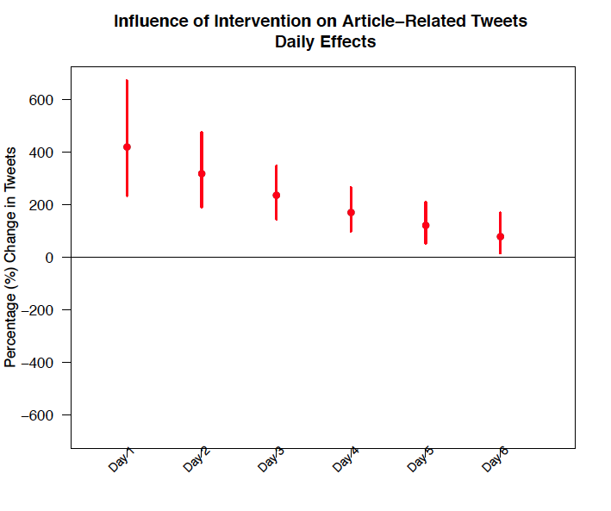

What’s truly interesting is that researchers found evidence that our collaborations may have had an influence on the wider subject area of a given topic. For example, that a story on the Dreamers might have had an influence on conversation around immigration as a whole.

This data is a bit more difficult to parse, but researchers believe they saw a 1.5% change in sentiment across all of Twitter. That may seem small, but it is statistically very significant.

buzz_overall_effect.pdf

King and his team are now preparing this data for publication. Unfortunately, the Media Consortium will not be able to make this data public until after the academic publication of the data.

However, we are not pausing our work just because the first phase is complete. The next step for us will be to run a second set of experiments to determine if we can grow the impact of our collaborations. We are working with Prof. King now to set up that experiment.

1. King’s seminal work on this topic can be found here: Daniel Hopkins and Gary King. 2010. “[A Method of Automated Nonparametric Content Analysis for Social Science](http://gking.harvard.edu/files/abs/words-Abs.shtml).” American Journal of Political Science, 1, 54: 229–247, 01/2010. Copy at <http://j.mp/1M2zFGN> [↑](#footnote-ref-1)
2. Stanford Social Innovation Review Winter 2011 [↑](#footnote-ref-2)