#WhoCounts? Barriers to Immigrant Voting in North Carolina

The legal battle against the Voter ID law has not yet been won. And even without the law, Latinx and Asian citizens face significant barriers to voting. Thank you for joining us tonight to learn how voter rights and changing demographics intersect in North Carolina.

Sponsors:

The Media Consortium is a national network of indpendent progressive news outlets. #WhoCounts North Carolina is one of a series of events the Media Consortium is holding around the United States. Find information on these events, and reporting on immigrant voting rights, at http://whocounts.tumblr.com/

The People’s Channel is Chapel Hill’s community TV station. Its mission is to advance democratic ideals by giving area residents and local non-profits an avenue to share their ideas, news and views, and to exercise free speech rights. Watch People’s Channel programming at Channel 18/ 97.3 in Durham or online at http://www.thepeopleschannel.org/wordpress/

#Who Counts North Carolina Panelists:

Alesha Brown, Staff Attorney
Southern Coalition for Social Justice

Alesha practices voting rights law at Southern Coalition for Social Justice. Prior to relocating to North Carolina, she served as Director of New York Law School’s Street Law Project and as counsel to New York City Council’s committee on Civil Rights. She earned her JD in 2012 from New York Law school, and her BA from the University of South Carolina.
Cat Bao Le, Executive Director
Southeast Asia Coalition

Cat is the founding Executive Director of the Southeast Asian Coalition (SEAC) in Charlotte. SEAC is the only Asian American social justice organization in North Carolina, and the first ever to focus on youth organizing, advocacy, and integrated voter engagement.
Juliana Cabrales
Mid-Atlantic Director of Civic Engagement
National Association of Latino Elected Officials (NALEO)

The NALEO Educational fund is the nation’s leading 501c3 organization that facilitates full Latino participation in the American political process.
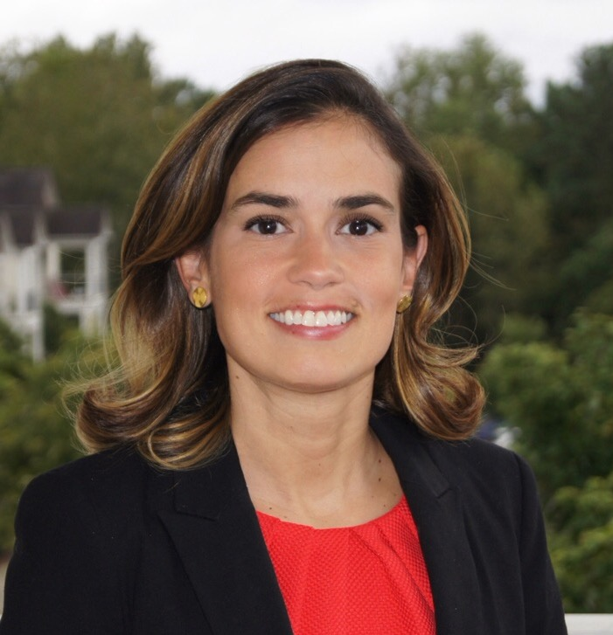
Allie Yee, Associate Director
Institute for Southern Studies

Allie is the Associate Director of the Institute for Southern Studies, a research, media and education center focused on the South. She researches demographic change, immigration, voting and civic engagement in the region and writes about these issues for the Institute's online magazine, Facing South.
