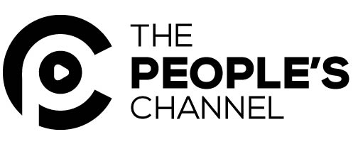

For Immediate Release Contact: Jo Ellen Green Kaiser
October 7, 2016 415.878.3862
joellen@themediaconsortium.org

Press Briefing: #WhoCounts? Barriers to Immigrant Voting in North Carolina

The legal battle against the Voter ID law has not yet been won. And even without the law, Latinx and Asian citizens face significant barriers to voting.

On Friday, October 14, the Media Consortium, a national network of independent news outlets, and the People’s Channel, Chapel Hill’s community TV station, will co-host a press briefing on barriers immigrant citizens face to voting in North Carolina. The briefing will be held at:

The Durham Main Library
300 N. Roxboro St., Durham
Friday, October 14, 4:00-6:00 PM
The public is welcome to attend

Immigration and Voter ID laws have both been significant national issues in the 2016 election that are too often covered separately. However, the realities on the ground in North Carolina show how the laws are connected.

The demographics of North Carolina are changing quickly. The population of Latinx immigrants has jumped from 4.7 to 8.6 %, the sixth fastest growth rate of Latinx in the nation (UNC Charlotte Urban Institute). The Asian American population in North Carolina is growing even faster—now at 3% of the population (Indy Week). These new residents—and frequently new citizens--face unique barriers to voting.

At the same time as North Carolina experiences this influx of new voters, however, it has been in the national news for attempting to restrict voting rights. A federal appeals court struck down North Carolina’s new Voter ID law in July 2016 but the legal battle has not yet been won.

Come to WhoCounts North Carolina to hear how voter rights and changing demographics intersect in North Carolina.

#Who Counts North Carolina Panelists:

Alesha Brown, Staff Attorney
Southern Coalition for Social Justice

Alesha practices voting rights law at Southern Coalition for Social Justice. Prior to relocating to North Carolina, she served as Director of New York Law School’s Street Law Project and as counsel to New York City Council’s committee on Civil Rights. She earned her JD in 2012 from New York Law school, and her BA from the University of South Carolina.
Cat Bao Le, Executive Director
Southeast Asia Coalition

Cat is the founding Executive Director of the Southeast Asian Coalition (SEAC) in Charlotte. SEAC is the only Asian American social justice organization in North Carolina, and the first ever to focus on youth organizing, advocacy, and integrated voter engagement.
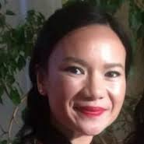
Juliana Cabrales
Mid-Atlantic Director of Civic Engagement
National Association of Latino Elected Officials (NALEO)

The NALEO Educational fund is the nation’s leading 501c3 organization that facilitates full Latino participation in the American political process.
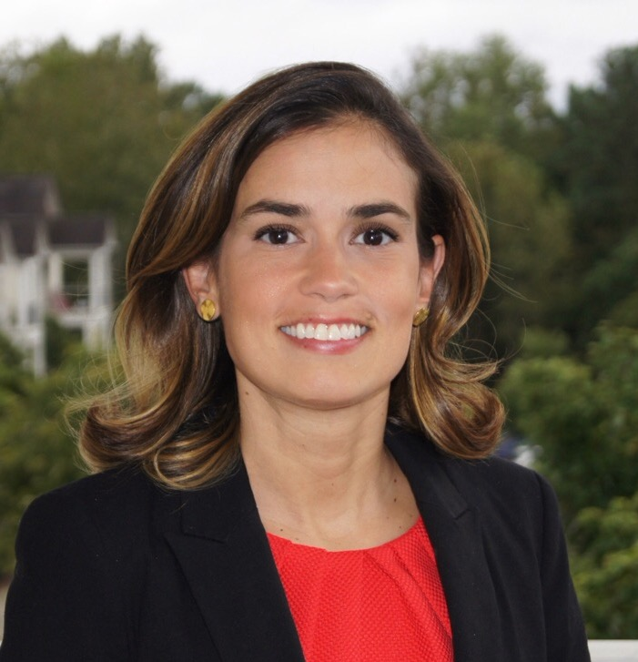
Allie Yee, Associate Director
Institute for Southern Studies

Allie is the Associate Director of the Institute for Southern Studies, a research, media and education center focused on the South. She researches demographic change, immigration, voting and civic engagement in the region and writes about these issues for the Institute's online magazine, Facing South.
