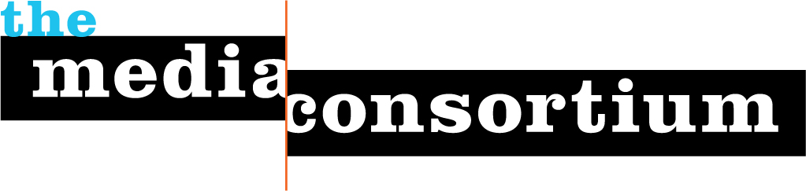

Project Proposal to the Chicago Community Trust
Collaborative Storytelling Project for On The Table 2017
Submitted March 10, 2017

- Executive Summary

The Media Consortium is a 501c3 network of independent and community media outlets dedicated to values-driven journalism. Founded in 2006, the Media Consortium grows the impact of member organizations through collaborations and partnerships that cross-pollinate communities with critically important stories.

Our Who Counts project in 2016 centered on reporting on immigrants, including a briefing that was attended by over 15 Chicago-based outlets and 10 community organizations. In February 2017, seven community-based Chicago outlets traveled to Washington, DC to participate in the Media Consortium’s annual meeting (thanks to generous support from MacArthur). We look forward to continuing and developing a strong network of Chicago-based community media.

- Scope of Work

The three objectives of this work will be:
- to foster new and substantive relationships among media outlets that serve different communities within Chicago;
- to support development of a local media network for collaborative storytelling that provides more complete stories of Chicago’s neighborhoods;
- and to expand the civic conversation nurtured at On the Table by helping to communicate the impact of those conversations in specific communities and neighborhoods.

This project is comprised of 8 components:

- Recruit 12-15 Chicago-based media platforms, focusing particularly on outlets engaged with self-identified communities, (e.g. Latino, African American, Chinese, LGBTQ, youth) to tell stories that better capture the breadth of On the Table conversations.
- Gather senior leadership from these outlets for an in-person meeting on Thursday, March 16 to provide a briefing about On the Table; to determine if the outlet is willing to either produce stories on and/or participate in an On the Table events; and to obtain firm commitments from the outlets on how they will engage in this collaborative effort.
- Provide these outlets with a Media Consortium membership and connect them with Chicago-based Media Consortium members to provide additional storytelling support.
- Manage logistical coordination with all participating journalists and storytellers to ensure they are fulfilling their commitments; to answer questions they may have; and to support their work.
- Help maintain a record of all stories published by this cohort about On the Table.
- Gather engagement statistics from the outlets (if they are available) about how widely these stories were read and how much audience engagement they elicited (such as facebook likes or comments); and qualitative feedback about the impact of On the Table on the outlets themselves.
- Provide a final two-page report detailing which outlets participated, and whether they hosted or otherwise engaged directly in On the Table events; a listing of stories produced; and an analysis of the impact of outlet storytelling on the wider perception of On the Table in the communities these outlets serve.
- Host a post-project meeting with participating outlets to evaluate their experience, and determine ways they can work together moving forward.

Please note: A core value of the Media Consortium is truth-telling. We will not dictate nor change the direction of a story, nor ask outlets to pull stories that are unfavorable to our funders.

- Timeline

Kick-off phone meeting with media outlets: March 14
Team meeting at the Trust: March 16
Follow-up coordination: March 16-May 16
Produce Report June 9

- Funding Request

Our total funding request is: $20,000

Project Manager (10 hours/week @ $75/hr for 3 months): $9000
Story production costs (12 outlets): $9850
TMC Memberships (12 outlets@ $75/outlet): $900
Grant Bookkeeping and Reporting: $250

- Team Background

The project lead for this collaborative storytelling project anchored by On the Table’s goal of civic conversations, will be the Media Consortium’s Associate Director, Manolia Charlotin. Deeply familiar with Chicago’s ethnic communities, Manolia is herself an immigrant of Haitian descent who speaks five languages. As a journalist who has led 3 community media outlets, Manolia understands the desire of these journalists and storytellers to tell the truth of their communities, and knows how to support them in their work. She has lead numerous collaborative media efforts, including 35 reporting collaborations among 40 of TMC members for our Metrics Project (with generous support from Voqal).

Submitted by:

Date
Signer, Title

