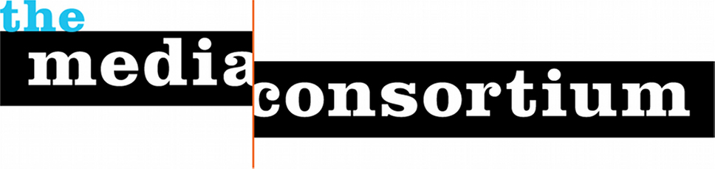

Independent Media Leaders to Convene in San Francisco

FOR IMMEDIATE RELEASE:

Leaders of top independent, alternative and progressive media outlets next month will gather in San Francisco for the first-ever joint conference held by the Association of Alternative Newsmedia (AAN) and The Media Consortium (TMC).

The 2015 AAN Digital/TMC annual conference, which will take place from Feb. 5-7, will allow some of the best minds in the industry to share their success stories, dish on the latest digital trends and push forward into the future of media.

"There's really important journalism going on these days in the independent media community - and this is the place to find out what's going on,” said Steve Katz, publisher of Mother Jones.

More than 200 editors, digital producers, advertising experts, social media curators and executives from around North America are expected to attend the conference at San Francisco’s Argonaut Hotel. There, they will trade stories on how to nationalize local news and localize national news; learn about complementary revenue models; and explore new monetization and digital ideas.

The conference will include keynote presentations from: Kara Swisher, co-CEO and co-executive editor of Re/code; Cenk Uygur, host and co-founder of the Internet news show The Young Turks; and Stephanie Brower, Head of LatAM Sales & Co-Head of Editorial Outreach at Chartbeat.

"This conference has always been a crucial gathering of independent, progressive publications – a place to connect with like-minded people in the field and share our unique experiences,” said Maya Schenwar, editor-in-chief of Truthout.

This year marks the 8th time AAN has held a digital conference for its 115 member organizations. The partnership with The Media Consortium – an international network of 75 leading independent, progressive journalism organizations – allows both groups to explore opportunities to develop a stronger independent news sector, AAN board president and publisher of the Boise Weekly Sally Freeman said.

“Our groups reach more than 150 million people around the world,” she said. “Together, we are an independent media force and can vigorously tackle the digital future.”

Registration is still open and conference sponsorships are still available. For more details, visit aandigital.com.

AAN is a diverse group of alternative news organizations throughout the United States and Canada. Its members are the original locals, proven to be scrappy innovators, not just in their news coverage, but also in their relentless dedication to bringing local communities to life and showcasing the best in each city they cover — in both editorial and business endeavors.

The Media Consortium is an international network of leading independent progressive journalism organizations. Reaching unusually diverse, engaged audiences, these outlets support smart high-impact journalism that redefines the political and cultural debate.

Contact Tiffany Shackelford
703 470 2996
tiffany@aan.org

