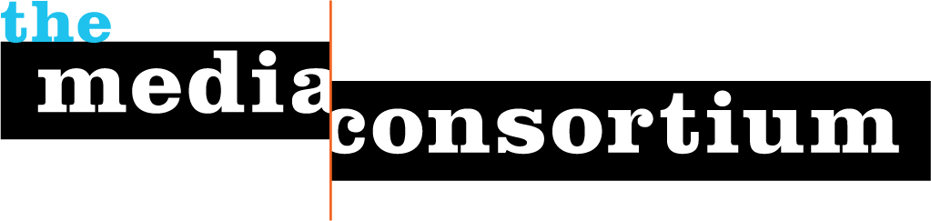
David Pakman Show
- Tell us about your organization’s mission and vision.
Our mission to be a leading independent, non-corporate-funded political and current events media outlet, an alternative to mainstream homogenous corporate media.
- Why do you want to join The Media Consortium?
Current TMC member media outlets are organizations very much in line with our mission and values, and it would be a great group to be a part of.
- How do you see your organization as a fit for The Media Consortium? Would you like to be an associate or full member?
Would discuss what is most logical with TMC staff.
- How would you describe your primary audience in terms of size, diversity/demographics, lifestyle and geography?
Our audience is estimated at 150,000 total across all platforms, including television, radio, and internet, and is distributed across the US, and in 5 additional countries where we have affiliate stations. The audience is mostly progressive, and very diverse in terms of background.
- What is your operating budget?
Under $250k per year
- How many staff do you have?
2 part time producers
- What are your primary platforms? (e.g., print, radio, online, video, tv, books, social networks, etc.)
150+ radio and television stations across the country, podcast, DirecTV & DISH network on Free Speech TV, youtube.
- How do you reach your audience? Please list subscriptions, online presence, listservs, or any other platforms (e.g., YouTube, MySpace, FaceBook) that your organization uses to engage your audience.
Online presense on itunes/podcast/website/youtube, 150+ affiliate radio and tv stations, facebook & twitter pages.
- What infrastructure is your organization looking to build? (e.g., advertising, web strategies, technological innovations, editorial planning, etc.)
Increased membership infrastructure is a top goal of ours to be able to provide additional diversity of content to subscribers of our show.
- Does your organization have any areas of expertise that could be helpful to The Media Consortium and its members?
David regularly does trainings, workshops, and consulting on social media and internet marketing strategies for grassroots and independent media outlets, and has presented at countless conferences on the subject.
- How does your organization fit into the progressive media network? (e.g., media producer, distributor, monitor, reform/justice, etc.)
Media producer
- Is your senior management willing and able to contribute to Consortium discussions, meetings, and projects?
Yes
- Who will be the primary MC contacts for your organization? (We recommend one editorial contact and one business contact.) These representatives will be expected to attend MC meetings, convey pertinent information regarding our projects to your staff, and ensure that your organization is involved in MC-related projects and conversations. If these contacts are unable to participate, who will serve this role in their place?
David Pakman will be the main contact.

