

Contact: Erin Polgreen
Erin@themediaconsortium.com
312.841.0553
www.themediaconsortium.org

Connect your community to the latest economic news and opinion

The Media Consortium has created an easy web 2.0 toolkit to connect your audience to news about the issues they care for. Economy.NewsLadder.net is a one-stop shop for the best independent reporting about the economy and economic policy reform. We believe that the more people have access to strong, independent reporting, the more we can positively impact the public and political dialogue. This project is highly beneficial to organizations looking to inform and engage their constituencies—or for publishers looking to offer more information to their audiences.
This project is completely free and offers up-to-date news and opinion from the country’s leading independent media outlets, including Mother Jones, New America Media, Talking Points Memo, The Nation, The Real News and Democracy Now.
How you can benefit:
1) Access the best independent reporting in the country at Economy.NewsLadder.net.
Sign up for an account at NewsLadder.net/register to join the community and post/share your organization’s latest news, or encourage your readers to vote on their favorite reporting.
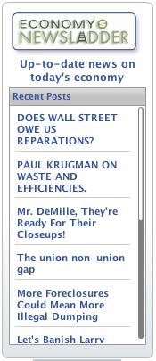
2) Publish The Weekly Audit: It’s hard to filter all the news on this critical issue. Every Tuesday, The Weekly Audit rounds up the best and most interesting journalism by leading independent media. It’s free for anyone to repost on their own sites—we'll even email the blog to you fully edited and coded, so that all you have to do is copy/paste. Click here for samples: http://www.themediaconsortium.org/author/zachcarter, then contact us to join the blog email list.
3) Post the Widget: Our simple headline widgets allow you carry up-to-the minute news about the economy on your website. These widgets are very easy to install (only copy/paste the code) and update 24/7. A sample widget is on the right. Visit http://is.gd/kQzZ for instructions.
We can also customize a widget for you! Let us know if you'd like to use a widget to help get the word out about a campaign. We can help design and distribute the final product.
4.) Host XML/RSS feeds: RSS feeds are a great way to offer the latest news without disrupting the look and feel of your site. To see a sample of the feeds in action, visit the following link: http://is.gd/t1DQ. The feed is in the middle, under the heading "news and opinion."

5.) Follow us on Twitter: Follow @EconomyNewsladr on Twitter to get the latest headlines.

