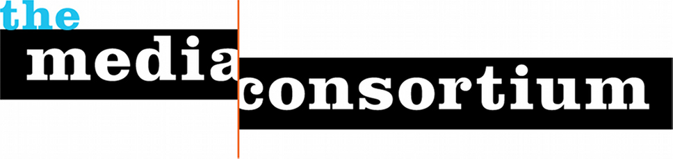

Who is the Media Consortium?

The Media Consortium (https://themediaconsortium.org) is a non-profit North American network of over 80 independent national news outlets, collectively reaching over 100 million people a day. Our member outlets are multiplatform—online, in print, and on the air. Prominent members include Colorlines, In These Times, The Nation, Democracy Now!, The Real News Network, Making Contact, Free Speect TV, Dissent Magazine, AlterNet and Grist.

TMC 2017 Transformative Media Conference

Goal
Independent news media are the first defenders of free speech in the Trump Era. Our mission—to tell the truth, to be the voice of dissent, to be the conscience of the nation—is critically important. When the public has lost trust in corporate news, ours if the trusted voice.

At this moment, to serve the public, we must transform how we see ourselves. No longer merely the "alternative" to mainstream media, can we start seeing ourselves as the most trusted and valued news outlets in the nation? Can we seize the opportunity to transform our media system?

Yes we can. We believe there is an opportunity with the failure of corporate media to create a new media system that is mission-based and values-driven. Among the values this new media system will share will be the journalistic values of accuracy and accountability, and the social values of inclusivity and equity. It will be a news media that puts communities (rather than journalists or politicians, etc..) at its center. Our democratic values are at stake. We must seize the moment to ensure the voice of all the people is heard by those who govern.

Top Objectives
1) Develop concrete ways to further editorial collaboration
Independent news outlets own niches. In order for them to transform the media system, they will need to work together. We have spent the past five years at the Media Consortium creating a collaborative culture, but what has gotten in the way are logistics--the fact that collaboration costs money. We need fresh thinking on how we can either get the money or make the processes easier.

2) Develop concrete ways to collaborate on marketing/promotion/distribution
In order to transform the media system, our members must be able to "show up" on the radar of influencers and the public. We need fresh thinking on how to get our content into the larger marketplace.

3) Renew our commitment to racial, geographic and class equity within our organizations
Last year, we devoted our conference to racial equity, with a full-day workshop led by Race Forward. Over 65 individuals attended that workshop--about half of all attendees at the conference. We need to continue to emphasize that we will not be living our values unless all our outlets are racially equitable. And this election demonstrates that we must also be geographically equitable. We need a renewed commitment to these values.

Method
One of the key values in independent media is centering community. Thus, to move forward on transforming the media ecosystem we will begin by centering the voices of the members of the independent media community.
The heart of this conference will be open space self-organized conversations on Thursday and Friday facilitated by Chris Michael.

A plenary conversation on Wednesday evening will provide us with energy and momentum to begin these conversations on Thursday; a pause on Friday morning with the more formal panel discussion structure will focus conversations. Because we want to come up with solutions, we are inviting a number of vendors and experts to bring their solutions into our space on Friday afternoon. We anticipate groups may visit with these vendors or invite them into their spaces.

We will end this part of our conference on Friday evening with commitments. Saturday is dedicated to providing Media Consortium members with content they need for the next year, although it is possible—and welcome--that some groups from Friday may want to continue meeting Saturday.

