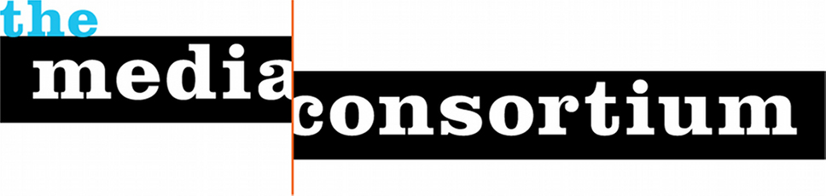

Who We Are
The Media Consortium is a national network of 80 progressive independent media outlets. We support smart, powerful and passionate journalism that redefines American political and cultural debate.

Our Mission
The Media Consortium’s mission is to support and grow the impact of the independent media sector.

Our Vision
We believe that independent media—media that are not owned by either multinational corporations or the government--play a vital role in democracy. Committed to fact-based journalism, independent media are driven by a mission to tell the truth to power. We tell the stories corporate media do not dare to tell.
At the Media Consortium, we believe words matter and can spur action. By supporting member outlets, amplifying their many voices, and leveraging their collective audiences, the Media Consortium aims to inform, educate, and engage communities in creating the world to which we all aspire.

Our History
The Media Consortium was founded in 2006. The country was at war in Iraq and Afghanistan under President George W. Bush. Media was under siege as the digital revolution upended old business models. The Media Consortium’s founders believed the only way to respond to this new environment was to work together, and so they founded a consortium, a member-run network.

By 2008, the Media Consortium had hired its first full-time staff, and begun to focus on pushing ahead of the digital curve by fostering innovation in its members. The Innovation and Incubation labs were born in 2009, and we published The Big Thaw, an overview of the field. In 2010, the Consortium introduced network‐wide editorial collaborations, first around key events and breaking, then around big ideas. In 2015 alone, the Media Consortium ran over 30 editorial collaborations on issues ranging from reproductive health to racial justice to climate change.

Looking forward to our next ten years, the Media Consortium is now embarking on a mission to ensure that our members embed principles of racial equity and justice in all aspects of our work. That is a necessary first step to partnering with other independent and community media around North America, in order to build a rich local-regional-national network of independent and community news.

To Find Out More about the Media Consortium go to www.themediaconsortium.org or Contact: Jo Ellen Green Kaiser, Executive Director, joellen@themediaconsortium.com

