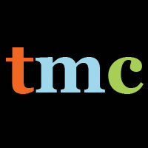

**Where is Your Plan B?**

**Who Has Access?**

Women on Reservations? NO

Immigrant Detainees? NO

Middle-Class, White, Suburban Women? THAT DEPENDS

On June 20, 2013, the FDA approved use of Plan B One-Step without a prescription. Media Consortium outlets ask: now that Plan B One-Step is legally available over the counter,is it easily accessible?

**How Accessible is Plan B One-Step for you?**

Go to your local pharmacy

Fill out our form at [www.whereisyourplanB.com](http://www.whereisyourplanB.com) Our site will map your response!

**Learn More: 8 Stories on Plan B Implementation**

* Native American Activists Fight for Plan B Access: Making Contact and Bitch Magazine
* Top 5 Roadblocks to Plan B Access: Ms. Magazine
* When the B Stands for Barriers: Leo Weekly
* Plan B Isn’t Truly Over the Counter in Portland: Portland Mercury
* From Abstinence Only to Plan Z: Austin Chronicle
* Who is Controlling Birth Control: Public News Service
* Abortion Access Under Fire in New Mexico: Santa Fe Reporter
* Immigrant Detainees Have no Plan B: In These Times

Whereisyourplanb is a project of the Media Consortium and the Association of Alternative Newsmedia, made possible by a generous grant from the Quixote Foundation

**Often Plan B One-Step is**

* Missing
* ID Required
* Locked Up

