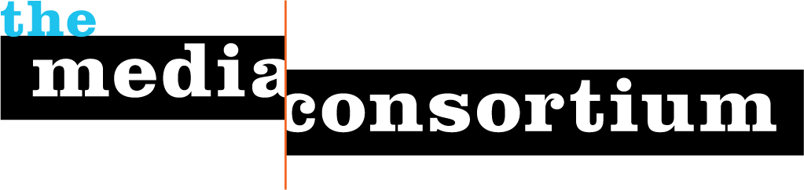

New Economies Agreement

Date of Agreement: May 10, 2017

Grantee: Waging Nonviolence
Purpose of Grant: Develop Reporting on New Economies
Total Amount of Grant: $1000
Award Date: May 10, 2017
Grant Period June 1, 2017-December 31, 2017

This grant is awarded by the Media Consortium subject to the following terms and conditions.

A. Grantee agrees to assign one reporter (may be self) to join at least 4 of the 6 live webinars the Media Consortium will produce during the Grant Period. Grantee agrees that the above reporter will listen/view any missed webinars via recording.

Reporter’s Name: __Sarah Aziza__________________________

Reporter’s Email: __sarahaziza17@gmail.com__________

Reporter’s Phone: ___815-218-5645______________________________________

B. Grantee agrees to produce the equivalent of 3 feature articles on topics germane to the New Economies beat within the grant period. Please specify below how this requirement will be filled:

I/We will produce 3 feature length stories.

[Example 1: I will write 3 feature length stories
Example 2: we will produce 3 segments of a radio show
Example 3: I will write 6 blog posts
Example 4: we will produce 1 10 minute video]

C. Grantee will agree to insert a pixel ping into digital content created in fulfillment of this grant. The Media Consortium will provide the pixel ping code.

D. Grantee will provide the Media Consortium with
1) the urls/pdfs/soundcloud of content produced for this grant
2) a brief one-page report based on questions provided to the Grantee

E. This grant may only be used for Grantee’s charitable and educational activities. Grantee may not use any Media Consortium grant funds to lobby or otherwise attempt to invludence legislation, to influence the outcome of any public election, or to carry on any voter registration drive. This grant must be used in the project identified above. Grantee accepts responsibility for complying with this agreements’ terms and conditions and will exercise full control over the grant and the expenditure of grant funds.

F. The Media Consortium reserves the right to discontinue, modify, or withhold any payments to be made under this grant or to require a total or partial refund of any grant funds if, in the Media Consortium’s sole discretion, such action is necessary (1) because Granteee has not fully complied with the terms and conditions of this grant; (2) to protect the purpose and objectives of the grant or any other charitable activities of the Media Consortium or its parent, the Foundation for National Progress; or (3) to comply with any lawy or regulation applicable to the Grantee, to the Media Consortium. Or this grant.

Grantees deposit or endorsement of the check Grantee receives will constitute agreement with the terms and conditions set forth above. However, for the Media Consortium’s files, please sign this agreement and return a pdf to the Media Consortium.

On behalf of Grantee, I understand and agree to the foregoing terms and conditions of the Media Consortium’s grant, and hereby certify my authority to execute this agreement on Grantee’s behalf.

Signature ___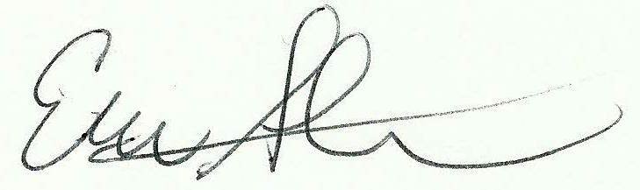_________________________________

Printed Name: ____Eric Stoner________________________________________________

Date: ___5/12/17______________________________________________________________

