To: Diane Tucker
From: Media Consortium Coordinating Committee

Media Consortium must bridge a cash flow gap—we need your help

Dear Diane,

We are writing to ask for your help to get The Media Consortium through a bit of a pinch. We know times are tight, but we are asking if you would advance us your 2013 dues now to get us through a short-term cash flow problem at the Media Consortium.

Here’s the situation: anticipated grants did not come through or have been delayed, so if we don’t raise $7,500 to cover July expenses, we’ll have to suspend operations. Ironically, this crunch comes at a time when the Consortium is stronger than ever.

- The May Day collaboration energized us, with 32 outlets contributing to joint reporting and publishing of the day’s news.
- Our Media Policy project has been highly successful, with six briefings resulting in 12 stories in just the past 2 months.
- The How it Works webinars have helped several of you rethink how you use key technology.

Our annual meeting in October brought us together to rethink how we could collaborate. Many of us are now working together on a regular basis, which increases our strength and impact exponentially.

As your Coordinating Committee, we are developing a financial plan that will diversify the Consortium’s revenue stream so that we won’t face this situation again. In the meantime, we are working to raise $22,500, or three months’ expenses, to create the cushion we need to get past this cash flow problem. You can solve the cash flow problem by paying forward your 2013 dues in the amount of $500.

Paying your dues in advance sends a strong message to the sector’s funders that you value the Media Consortium. We understand you may be stretched, but we would like to be able to go back to major funders with the news that our members have gone above and beyond their commitments by paying next year’s dues.

One of us will call you in the next couple of days to talk over the situation and to fill you in on more details of our plans.

Thank you for your support. Talk to you soon.

Sincerely,

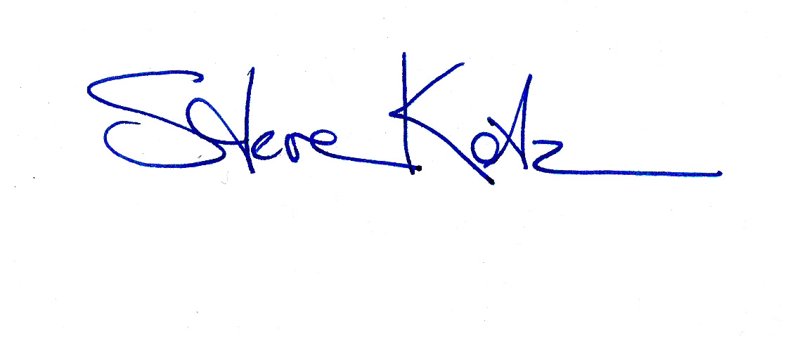
Steve Katz, Mother Jones; Chair, TMC Coordinating Committee

Rinku Sen, Colorlines; Past Chair, TMC Coordinating Committee
Jason Barnett, Uptake
Eric Galatas, FSTV
Linda Jue, George Washington Williams Center
Lisa Rudman, Making Contact
Cindy Samuels, Care2
Maya Schenwar, Truthout
Alan Searle, FSRN

P.S. Dues checks should be made out to the Media Consortium and sent to the Foundation for National Progress, Attn: Kevin Medford, 222 Sutter St, Ste 600, San Francisco CA 94108. Please add “Media Consortium dues, 2012 and 2013” to the notes line.

