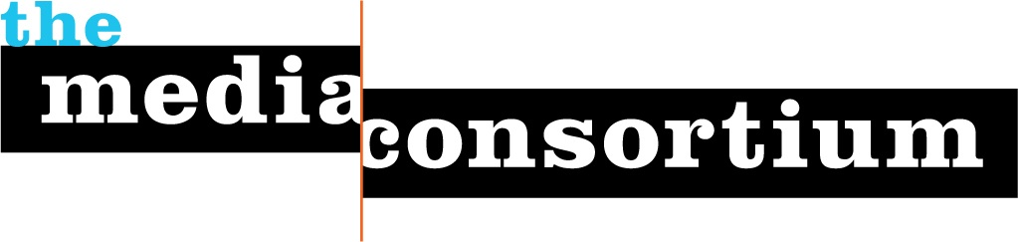
For Immediate Release: June 15, 2010

For More Information, contact:
Erin Polgreen, Senior Program Associate
erin@themediaconsortium.com/ 312.841.0553
http://www.themediaconsortium.org/thebigthaw
Twitter: @tmcmedia, #ussfwire

The Media Consortium, network of country’s leading
independent media organizations, announces ground-breaking collaborative effort to cover the US Social Forum
Over a dozen media outlets and non-profit allies to participate in USSFwire, delivering a stream of breaking news and collaborative reporting.

Progressive news stream unveiled for US Social Forum. From June 21-26, over a dozen media organizations will collaborate to distribute breaking stories from the 2010 US Social Forum (USSF) in Detroit, MI. The Media Consortium (TMC), a network of the country’s leading progressive media outlets, is proud to announce the debut of the USSFwire news-sharing project, which will distribute unique, in-depth media content to over 40 TMC members, additional media organizations and social justice groups around the country during the USSF.

Over ten thousand of activists and media professionals will convene in Detroit for the 2010 USSF to discuss and act on a wide variety of social justice issues. The USSFwire project will increase awareness of the issues addressed at the USSF and provide media and non-profit organizations with breaking reporting and fresh multimedia content to engage their constituencies and

Participating media producers include the People’s Media Center at the USSF, Colorlines, Public News Service, Yes! Magazine, FreeSpeechTV, GRITtv, Inter Press Service, The Progressive, Truthout, the National Radio Project, In These Times and more.

The Tools
The Media Consortium has set up a series of tools to facilitate any media or non-profit organization to receive and feature USSF content. They include the USSFwire Headline Widgets, the Syndication Feed and daily top story alerts.

Here’s how you can participate, submit and receive content:
- Host a USSF headline widget on your site, or use the USSFwire to share media content for syndication/republishing. Headline feeds and stories will be hosted on the People's Media Center NewsHub, among other places.
- Sign up for our daily top story alerts by emailing erin@themediaconsortium.com. Alerts will arrive in your inbox at noon everyday from June 22-26. This content will be available for any organization to syndicate, so long as it credits the original source.

Join Us!
We’re working to increase the size and scope of this project. If you want to deliver your reporting on USSF to a wider audience, or want to keep your audience engaged in this important event, contact us to learn how you can use these tools.

About The Media Consortium
The Media Consortium is a network of over 40 leading, progressive, independent media outlets from print, radio, online, and television including Mother Jones, The Nation, AlterNet, Link TV and more. It was formed five years ago to amplify independent media's voice, increase its collective clout, leverage current audiences and reach new ones, and last but not least, seize the moment to change the national debate. For the last five years, The Media Consortium has been on the front lines of the changing media landscape and is leading independent media outlets into a new era for journalism. (http://www.themediaconsortium.org)
—40—

