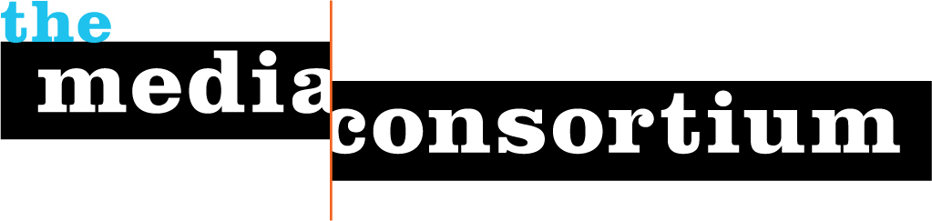
Membership Screening Questionnaire
Any information gathered during this process is for private consideration by the Media Consortium's membership committee and will not be released without the permission of the organization applying for membership.
Please return this questionnaire to Jo Ellen Green Kaiser at joellen@themediaconsortium.com.
- Toward Freedom has been offering a progressive perspective on world events since 1952. Toward Freedom (TF) envisions a world ethic that honors the human spirit and the right of individuals to freedom of thought and creativity; advances movements for human rights, peace, justice, enlightenment, and freedom from oppression; and celebrates the contributions of the world's diverse cultures.
- We want to join TMC because we see it as a network of likeminded media outlets, whom by working together, can assist in transforming the media landscape. We believe that TF would be a nice fit with TMC as we have a long history of reporting on progressive world events since 1952. We have a wide network of subscribers. We are active in our local community of Burlington, Vermont by way of bringing in speakers, authors, and media activists. We would like to be associate members.
- Most of our audience is based in the US, UK and Canada. We receive roughly 100,000 unique visitors per year to our site. Our general audience is made up of activists, students, academics, and people involved in social justice, non-profit and international solidarity work.
- What is your operating budget? Approximately $25,000 a year.
- We have one paid staff member and an active board of directors.
- We are looking to build
- Our primary platforms are our website, our email newsletter, and Facebook .
- Our strongest areas of expertise are in our reporting on Latin American politics and protest movements, and in our general international coverage from the reporters on the ground in Africa, Europe, Asia and Latin America.
- Is your senior management willing and able to contribute to Consortium discussions, meetings, and projects? Yes.
- Who will be the primary MC contacts for your organization? Sam Mayfield and Ben Dangl. Sam Mayfield has served on the TF board for over five years . Ben Dangl, our web editor, is paid staff. If we are unavailable to participate in TMC events, Robin Lloyd our board chair, will act in our place.

