

October 2nd, 2007

To Whom It May Concern,

Re: “Live From Mainstreet with Laura Flanders”
The Real News Network & The Media Consortium

I am writing this letter to advise you of our support of the above-noted project.

The Real News is eager to partner with the Media Consortium in supporting "Live from Mainstreet with Laura Flanders." To that end, the Real News has committed $35,000 towards production expenses, assuming the project raises sufficient funds to go into production. The Real News expects to use at least some of the content produced by the project on our own website www.therealnews.com and that of one of our content partners YouTube.

Should you require any additional information please do not hesitate to contact me.

Sincerely,
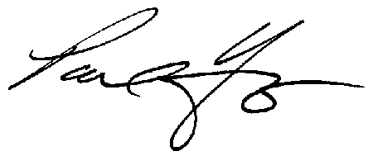

Paul Jay
CEO & Senior Editor

PJ/dn

