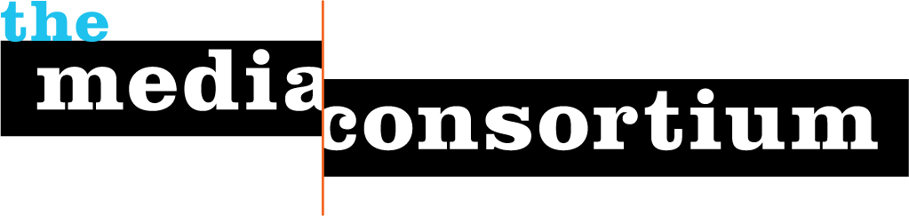

Who We Are
The Media Consortium is a national network of progressive independent media outlets. We support smart, powerful and passionate journalism that redefines American political and cultural debate.

Our Mission
The Media Consortium’s mission is to support and grow the independent media sector.

Our Vision
We believe that independent media—media that are not owned by either multinational corporations or the government--play a vital role in democracy. Independent media are driven by a mission to tell the truth to power. We tell the stories corporate media do not dare to tell.

Media Consortium members seek to inform, educate, and engage citizens in creating the world to which we all aspire. Committed to fact-based journalism, Media Consortium members believe words matter and can spur action.

By supporting member outlets, amplifying their many voices, and leveraging their collective audiences, the Media Consortium aims to grow the influence and visibility of the sector. Our goal is to take back the media from a handful of corporate oligopolies, and restore healthy and vibrant debate to this country.

Our History
The Media Consortium was founded in 2006. The country was at war in Iraq and Afghanistan under President George W. Bush. Media was under siege as the digital revolution upended old business models. The Media Consortium’s founders believed the only way to respond to this new environment was to work together, and so they founded a consortium, a member-run network.

By 2008, the Media Consortium had hired its first full-time staff, and begun to focus on pushing ahead of the digital curve by fostering innovation in its members. The Innovation and Incubation labs were born in 2009, and we published The Big Thaw, an overview of the field. In 2010, the Consortium introduced network-wide editorial collaborations, first around key events and breaking news (the Social Forum meeting in Copenhagen; labor protests in Wisconsin), then around big ideas (media policy, campaign cash). Today, the Consortium pursues both tracks, the Innovation and Incubation Labs and editorial collaborations, in order to fulfill our mission and vision.

To Find Out More about the Media Consortium to to www.themediaconsortium.org or
Contact: Jo Ellen Green Kaiser, Executive Director, joellen@themediaconsortium.com

