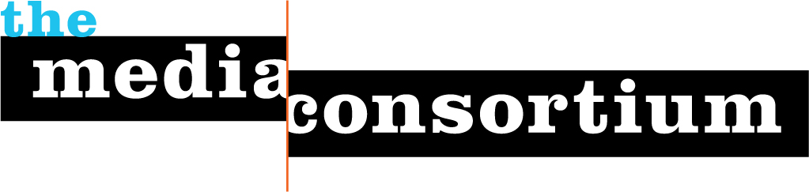

**The Media Consortium’s mission:** to amplify independent media’s voice, increase our collective clout, leverage our current audience and reach new ones. We believe it is possible and necessary to seize the current moment and change the debate in this country.  We will accomplish this mission by fulfilling our five strategic principles:

* Foster Collaboration and Coordination
* Build and Diversify Media Leadership
* Focus on Audience Development
* Bring Money and Attention into the Sector
* Support Innovation in Journalism and Business Models

All Media Consortium projects are based on the organization’s mission and fall under one or more of our strategic principles.

**The Incubation and Innovation Lab**

The Incubation and Innovation Lab is The Media Consortium’s dynamic new program to support its members in conducting rapid prototyping as a low-cost way to test new business, technology and content development models at a scale that they would not be able to achieve alone.

This two-part program helps our members research, discuss and experiment with new business, publishing and editorial models that take advantage of the new, web-enabled reader/publisher relationships. The two components to this program are the Digital Refresh Workshop and Small Group Labs.

Digital Refresh Workshop

The Digital Refresh Workshop is a three-month turbo charge for Media Consortium members’ digital operations. This workshop will provide intensive hands-on support and training to help our members analyze, understand, and innovate around key digital strategies, including list/community building, revenue generation and how to harness new journalism production strategies. By the end of the workshop, participating organizations will have completed an in-depth analysis of their current digital profiles, determined future goals to revamp their digital strategies, and will take the first step towards launching an experiment to reach those goals.

The Digital Refresh workshop will provide members with cutting edge tools and smart guidance to achieve ongoing innovation for long-term sustainability and impact. **To get an application for the workshop, please email** tracy@themediaconsortium.com**. The deadline to apply is March 10.** As we are just launching the Digital Refresh Workshop, we will select three member organizations to work with throughout summer/early fall 2010. TMC Workshop leaders will decide on these three organizations based on the ability of that organization to commit to the requirements and to ensure that we work with a diversity of organizations. As we continue this program, we look to expand the number of participants.

Small Group Labs

The Small Group Labs will be debuting in Spring/Summer 2010. The Media Consortium will organize a small group of TMC members to work with each other and outside experts to generate one or more experiments in mobile, revenue-generation, journalism and community building models. The Small Group Labs will also allow members to trade experiences, share information, and find answers to ongoing questions. Members will not only discover the best strategies for their organizations, but how to implement them—a critical component of ongoing success. In addition, The Media Consortium will provide seed money for experiments developed in the small group labs.

At the end of the lab cycle, participating members will share experiences and lessons learned with MC members and allies, creating a ripple effect in which education, deployment of practices and evolution of experiments moves outward to benefit the whole independent media sector. Experimentation will create strategies and space for media outlets to identify and implement a long-term formula for ongoing sustainability and impact that will support their critical journalism.

**The MediaWires**

The MediaWires project is booming. Our weekly blogs—that's The Audit, The Pulse, The Diaspora and The Mulch—are performing very well and helping increase traffic and awareness of your content and the independent media sector at large.

After a test period this summer, we kicked the Weekly Mulch into high gear. During the Cop15 climate convention, TMC intern Alison Hamm wrote six posts that contextualized and featured members' content. Thanks to her work, three new organizations are republishing the Mulch. Sarah Laskow, the newest edition to the TMC blogging family, joined immediately before the holidays.  
  
The Weekly Diaspora, our immigration-focused blog, will be back with a new blogger on March 4. Our new blogger, Erin Rosa, is an Associate Editor for Campus Progress and has a strong background as an investigative reporter. We’re happy to have her on board!

We're very excited to announce that CurrentTV will be featuring the blogs as a part of their blogging and community site. Other new publishing partners include OneClimate.net, The Climate Community, The Smirking Chimp, and more. Contact Erin Polgreen at [erin@themediaconsortium.com](mailto:erin@themediaconsortium.com) for information about how you can be involved with this project.

**Internship Program**

The Consortium’s Independent Media Internship program has just begun for the Spring semester and we've placed interns at *Yes! Magazine*, Link TV and the Washington Independent, among others.

Last year we placed 10 diverse, highly talented interns with Media Consortium members. In addition, TMC staff organized monthly professional development calls in partnership with Free Press on subjects that ranged from the economics of independent journalism to a media policy 101. The calls were a great resource for interns and we're pleased to announce that this year, we'll be opening up these calls to interns of any Media Consortium member organization.

We’ll begin accepting member applications to receive a summer intern on February 23, so be sure to check your inboxes, or contact Jeanne Brooks at Jeanne@themediaconsortium.com.

**The Big Thaw**

In October, we released *The Big Thaw: Charting a New Course for Journalism*, a year-long study focusing on how independent media can lead in the future media landscape. Blog posts and a slideshow breaking down the study are available on [www.themediaconsortium.org/thebigthaw](http://www.themediaconsortium.org/thebigthaw" \t "_blank). We've received positive feedback about the study from foundations, academics and journalists around the country. *The Big Thaw* has been tweeted about, read by leading thinkers, blogged about by community and citizen journalists, and even used in the classroom. John Bracken of the MacArthur Foundation included it in his list of 2009's [Most Influential Media About Media](http://bracken.wordpress.com/2009/12/24/2009s-most-influential-media-about-media/" \t "_blank).  
  
Josh Stearns wrote for Savethenews.org, “*The Big Thaw* … is refreshingly different from every other report published this year. Whereas most reports focus on what went wrong with journalism in America and consider new models and experiments currently under way, *The Big Thaw* delves into the future. … It reads less like a report and more like a travel guide of what’s to come, giving the reader a glimpse at an exciting new landscape.” To download your own copy of The Big Thaw, visit [http://www.themediaconsortium.org/thebigthaw/download](http://www.themediaconsortium.org/thebigthaw/download" \t "_blank).