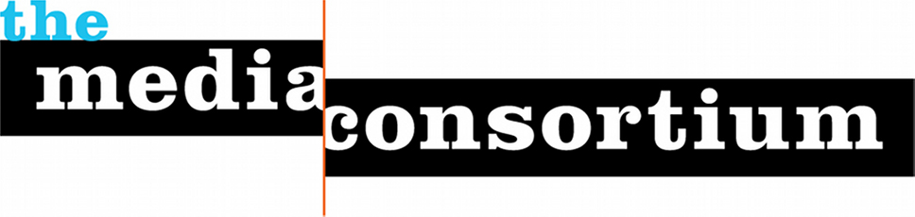
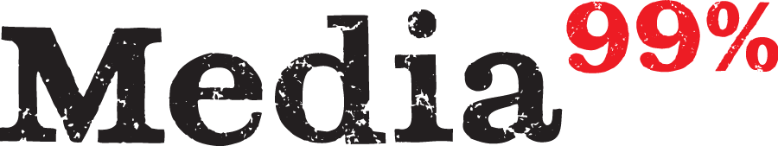

For Immediate Release: April 18, 2012
Contact: Jo Ellen Green Kaiser, Executive Director
joellen@themediaconsortium.com/ 415-878-3862

Media for the 99 Percent Challenges Corporate Media with National May Day Coverage

This year, International and Immigrant Workers Day, May Day, will usher in a spring of protest fueled by a reemergent Occupy movement poised to challenge corporate power, voter suppression, and a lopsided economic recovery. Convinced that multinational corporate media will not tell the May Day story accurately, over 25 independent outlets belonging to the Media Consortium will collaborate to offer competing national coverage.

Calling themselves “Media for the 99 percent” (www.mediaforthe99percent.com), these outlets will offer live TV, sophisticated infographics, breaking news reportage, and coordinated social media coverage across their sites, reaching a combined audience of over 50 million Americans.

Independent media outlets have stayed with the Occupy story through the winter with unparalleled reporting: books by Yes! magazine and AlterNet; a weekly TV show from Free Speech TV; cover features by In These Times, the American Prospect, the Nation and Mother Jones; in-depth and breaking news reporting by Truthout, Making Contact, the Public News Service, Free Speech Radio News, and many others.

On May Day, our outlets will leverage our existing platforms and reporters to provide coordinated national coverage through:
- Interactive Map. The map will show the public where May Day actions are happening and give the public access to Media Consortium outlets’ reporting on these events.
- MayDay TV Show. FreeSpeech TV will broadcast a live and livestreamed TV show featuring skyped reports from actions around the country, as well as in-house commentary from experts.
- Social Media Campaign: A storify will offer a narrative of breaking news that will support a crosspromotional campaign around a set of twitter hashtags, the map, and the TV show.

All three tools are available for embedding .

TMC Director Jo Ellen Green Kaiser is available for interviews. Please contact her directly.

