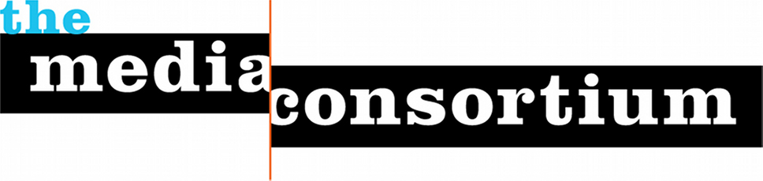
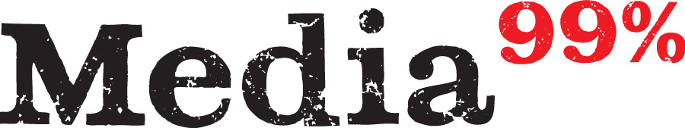

For Immediate Release: April 24, 2012
Contact: Jo Ellen Green Kaiser, Executive Director
joellen@themediaconsortium.com/ 415-878-3862

Media for the 99 Percent Challenges Corporate Media with National May Day Coverage

May Day this year will usher in a spring of protest fueled by a reemergent Occupy movement . Convinced that multinational corporate media will not tell the May Day story accurately, the sixty independent news outlets belonging to the Media Consortium will collaborate to offer competing national coverage.

Calling themselves “Media for the 99 percent” (www.mediaforthe99percent.com), these outlets will offer an innovative, groundbreaking paradigm for national coverage. Media for the 99% outlets will coordinate to produce live TV, sophisticated infographics, breaking news reportage, and social media coverage. Instead of placing all this coverage on one branded, national site, coverage will be distributed across multiple media sites, reaching a combined audience of over 50 million Americans.

New social media tools allow for this kind of dispersed coverage. On May Day, outlets will leverage existing platforms and reporters to provide coordinated national coverage through:
- Interactive Map. This embeddable Google Fusion map will show the public where May Day actions are happening and provide links Media Consortium outlets’ reporting on these events.
- MayDay TV Show. FreeSpeech TV will livestream as well as broadcast a live TV show featuring skyped reports from actions around the country, as well as in-house commentary from experts.
- Social Media Campaign: A storify will offer a narrative of breaking news that will support a crosspromotional campaign around a set of twitter hashtags, the map, and the TV show.

These three tools will be absolutely free to any website, including those not participating in the actual collaboration. That’s because the primary aim of the collaboration is impact—educating the public about the day and giving them the information they need to participate in the actions. This dispersed coverage is also designed to strengthen both the individual outlets and the independent sector as a whole.

Occupytogether.com and Occupy.com plan to run at least two of these tools. Among the media outlets The Nation, Mother Jones, AlterNet, Dissent, LinkTV, Free Speech Radio News and Yes! are all planning May Day landing pages based on these tools.

Get an advance look at some of the tools and folllow the story of the collaboration as it develops at http://www.mediaforthe99percent.com (going live May 25). TMC Executive Director Jo Ellen Green Kaiser is available for interviews. Contact: 415-878-3862

