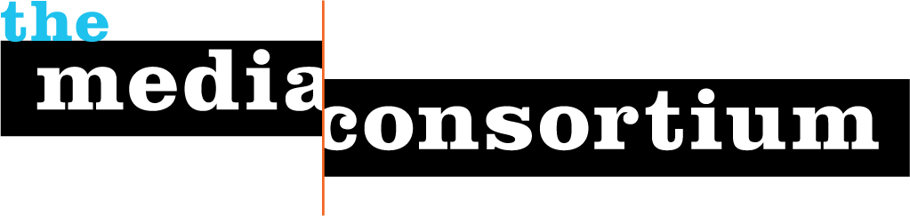
Program Profile: Independent Media Internships
"[Our intern] is years ahead of her peers and on equal footing with many media pros who have five years experience. She is a natural." Beau Friedlander, Air America
"I am learning so much about ... new media, editing, writing, and countless other things that this internship entails. I think this experience will turn out to be really valuable as I move on to a career in independent media." OneWorld US intern
Introduction
In summer 2009, The Media Consortium debuted a unique, national media internship program that is engaging young people in the political process and building a strong, diverse network of savvy independent media leaders.
As a part of The Media Consortium’s commitment to supporting media outlets that inform and shape our democracy, as well as our dedication to cultivating the next generation of media leaders, the Independent Media Internship program is a low cost, high impact component to our programming.
Cindy Von Quednow, who interned with the Applied Research Center/ColorLines authored a groundbreaking report on the impact of the recession on ethnic media, which garnered the 4th highest page views of all time for ColorLines.com. Another intern made the front page of the Huffington Post with a blog on the role of Twitter in the Iranian election protests. The second round of interns began in September 2009 and interns for Winter 2010 are currently in session.
By engaging passionate voices at an early age and providing them with a tool kit for success, The Media Consortium is fostering a generation of media leaders that are committed to telling key stories, engaging with emerging technologies, asking hard questions and inciting debate around vital political issues.
What does the program look like?
The Independent Media Internships are for politically active, civically engaged, undergrad and graduate students who are passionate about independent media. Using hands-on learning, mentorship, and career-training workshops in a variety of media fields (audio, video, print, online), we are developing the next generation of thinkers, writers and reporters that will give voice to issues impacting every day Americans. Their work is critical to informing and engaging communities in the political process.
We foster young writers’ knowledge of key political and social issues, including: immigration, health care, economics, the political process, civil rights and international relations. Investing in young media makers is beneficial for journalism as an institution, government, and American citizens.
With current funds, Media Consortium staff are identifying and placing 12 interns with member organizations over two four-month periods in 2010 and providing a stipend of $2,000 for twelve 32-hour workweeks. Over this four-month period, interns complete one or more major editorial projects, complete weekly duties (including fact-checking, research, writing and multimedia production) and meet with top editors and reporters for mentoring sessions.
Interns also participate in monthly professional development conference calls, which Media Consortium staff co-organize with Free Press. We are providing channels for the interns to network/build professional support systems and learn from leading practitioners in the fields of journalism, new media and media policy.
We have partnered with universities and other internship placement programs to recruit students committed to the practice of journalism as a means of strengthening democracy and public dialogue. To date, hundreds of students from a variety of economic, cultural, and educational backgrounds have applied. These applicants are smart, engaged, global citizens who are passionate about the power of journalism to transform democracy.
We place interns across the spectrum of media platforms. Organizations that have participated in this program include: Air America, The American Prospect, GritTV, RH Reality Check, ColorLines, LinkTV, Talking Points Memo, Mother Jones, the American Independent, Yes! Magazine and more.
What is this program’s impact?
The Independent Media Internship program is a natural outgrowth of The Media Consortium’s core mission and vision: Not only does is allow us to shore up and support our members, but it is also a necessary investment in the future of journalism that informs and shapes a vital democracy.
Most media internships are unpaid and offer little support to young journalists—this program ensures that passionate young people have the financial support and mentorship necessary to build a vibrant career in the media. Paid internships are also crucial to ensuring that the next generation of media leaders come from a diversity of economic and cultural backgrounds. By recruiting young people from a variety of communities, we are helping create the megaphone with which our future journalists will make the issues important to their communities heard.
About The Media Consortium
Founded in 2005, The Media Consortium is a network of over 40 leading independent journalism organizations that work in print, online, on television, and on the radio. We support smart, powerful and passionate journalism that redefines American political and cultural debate. The Media Consortium is creating a solid cooperative infrastructure that will serve a 21st-century audience and offer a sustainable future for independent media. Millions of Americans are looking for honest, fair, and accurate journalism. We’re finding new ways to reach them. Our current members are:

Afro-Netizen
AlterNet
American Forum
The American Independent News Network
The American Prospect
Balcony Films
Brave New Films
Berrett-Koehler Publishers
Campus Progress
ColorLines
Democracy Now!
Feministing.com
Free Speech TV
G. W. Williams Center for Independent Journalism
GlobalVision/Media Channel
Grist.org
GRITtv
Hightower Lowdown
Huffington Post Investigative Fund
In These Times
Inter Press News Service
LinkTV
Mother Jones
Ms. Magazine
The Nation
The Nation Institute
National Alliance for Media Arts and Culture (NAMAC)
National Radio Project
New America Media
The New Press
OneWorld US
The Progressive
Public News Service
RealTV/IWT
Regional News Network
Talking Points Memo
Texas Observer
The Uptake
The Washington Monthly
Women’s Media Center
YES! Magazine
The Young Turks

