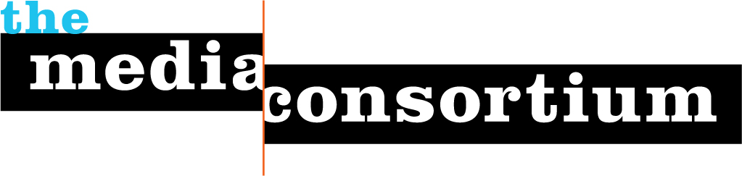

Dear Sam,

I’m thrilled to hear about the work of the American Independent Institute—a foundation dedicated to funding deep-dive investigative journalism that exposes DC dirty dealings and the misguided strategies of right-wing politicians is so welcome!

As I told you, the Media Consortium hosts annual Impact Awards to inspire our members to create high-impact stories. What’s unique about our awards is that we require winners to give a short talk about how they believe they achieved their impact. Steve Katz, for example, explained that Mother Jones was only able to obtain the 47% video by investing in a DC office; Rinku Sen of Colorlines described how their pieces on undocumented workers had more impact because they were part of the DroptheI-word campaign; other winners have described social media campaigns, reporting techniques and more. The result is that the awards not only honor current winners but educate future winners.

We are looking for a sponsor for this year’s awards, and the American Independent Institute would be a perfect fit. As the sponsor, your name would be on our program and signage, and you would be thanked from the podium, including by our special guest speaker, Toby Thompkins, Vice President of the Tides Foundation. Since the awards are being given on Friday evening, at the mid-point of the conference, (and since they will be open this year to our friends at AAN as well as TMC), we fully expect most of the 250+ attendees to be present. At just $4000, this is a low-cost opportunity to get your Institute’s name out to a large number of editors and publishers across the country.

I’ve attached a description of the Awards event and of the sponsorship benefits. If you were interested, we could even talk about a multi-year named sponsorship opportunity. Please let me know if you need any other information.

Sincerely,

Jo Ellen Green Kaiser
Executive Director, The Media Consortium

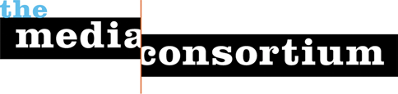

Third Annual Impact Awards 2015

Each year, the Media Consortium gives out awards for the stories that have had the greatest impact the preceeding year. In 2015, at our annual conference February 5-7 in San Francsico, we will be giving out up to 5 awards.

At the ceremony, our judges, the editors at The New Press, will describe the impact each winner had. Then, winners will be asked to speak briefly about how they believe they achieved that impact. The ceremony thus both honors current winners and educates future winners.

This year, the ceremony will be introduced by Toby Thompkins, the Vice President of the Tides Foundation. The ceremony will be followed by a reception. We expect 250 editors and publishers to attend the ceremony.

$4,000 Impact Awards Sponsor

- Opportunity to put your name front and center during welcoming remarks as well as high profile throughout the conference.
- Welcoming remarks at the Awards ceremony
- Exhibit space and two conference registrations
- Recognition at the convention
- Insert and promotional item (provided by the sponsor) in the attendee welcome materials
- Logo and leaderboard ad placed in convention e-mail newsletters
- Logo (linked) and 60-word description on Sponsors page on convention website and in program

For more information, please call 415.878.3862 or email joellen@themediaconsortium.com

