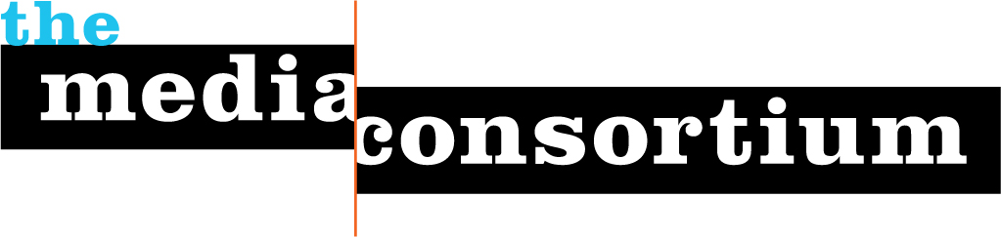
Submitted by: The Media Consortium, a project of the Foundation for National Progress
Submitted to: Quixote Foundation
Date: December 31, 2013
Submitted by: Jo Ellen Green Kaiser, Executive Director

Final Report: Where is Your Plan B

“As activists and advocates who work to improve access to emergency contraception, we were thrilled to learn about The Media Consortium’s “Where Is Your Plan B?” project. The American Society for Emergency Contraception (ASEC) was also collecting data on how Plan B One-Step was being sold after the OTC approval, and we connected with Jo Ellen to figure out how we could join forces and get the most out of our collective efforts. We were able to harmonize our data collection instruments so that we can report our results as a whole. The Media Consortium will transfer the “Where Is Your Plan B?” site to ASEC, and we will use this resource to keep pressure on retailers to stock Plan B One-Step on the shelf and keep this issue at the forefront. Thank you for your excellent work and collaboration!” – Kelly Cleland, Executive Director, American Society for Emergency Contraception/Princeton University

Content Launch

Whereisyourplanb.com launched on October 7, 2013. The launch was accompanied by a vigorous social media campaign using the hashtag #whereismyplanb. At the time of the launch, four of the stories were live, including:
- Top 5 Roadblocks to Plan B Access, Ms. Magazine
- Native American Activists Fight for Plan B Access, Bitch and Making Contact
- When the B Stands for Barriers, Leo Weekly
- From Abstinence Only to Plan Z, Austin Chronicle

On October 10, 2013, three more stories went live:
- Who is Controlling Birth Control, Public News Service
- Abortion Access Under Fire in New Mexico, Santa Fe Reporter
- Plan B Isn’t Truly Over the Counter in Portland, Portland Mercury

One final story will be out by October 25.

Promotion

Following a marketing plan created by Tiffany S., The Media Consortium and the Association of Alternative Newsmedia sent our emails asking organizations and individuals to promote the site and the hashtag. Emails were sent to:

- The Media Consortium list
- The Assocation of Alternative Newsmedia list
- A list of 400 women’s health reporters (generated using Vocus)
- A list of 40 media reporters
- Individuals and organizations that had been touched by this project.

In addition, the Quixote Foundation sent out their own round of emails, as did the ten news organizations who participated in the collaboration. TMC member feministing.com, which was not part of the project, very generously sent out a large number of tweets/facebooks to their following, as did several other TMC members.

Starting on October 8, 2013, TMC and AAN joined to hire a freelancer to promote the site under the handle “WhereisYourPlanB.” That freelancer will continue to work until October 25.

Publicity Success

The project got an early injection as well from a story about the collaboration produced by Mother Jones and published on October 7, 2013: http://www.motherjones.com/mojo/2013/10/how-easy-it-get-plan-b

On Friday, October 18, the nationally syndicated radio show Counterspin devoted a 10 minute segment to the project with an interview with TMC ED Jo Ellen Kaiser.
http://fair.org/counterspin-radio/simone-campbell-on-shutdown-jo-ellen-green-kaiser-on-where-is-your-plan-b/

Metrics

After two weeks, we can report the following metrics:

2140 page views
1,198 visitors
916 unique visitors
average time of visit: 2:16
23% of visitors returned to the site

As expected, the highest number of visitors was on 10/7; the lowest was on the weekend of 10/12-10/13:

The sources of the visits demonstrated that the promotion campaign managed to touch individuals in multiple ways, as visitors came from a well-distributed number of sources:

Impact—Direct Action

One way to measure impact is to look at how many visitors filled out the crowdsourcing form. The form requires participants to physically go to a location that sells pharmaceuticals, ask questions, and then enter responses in the form. Because of this high level of engagement, expectations are low in terms of participation. We were quite pleased with the level of participation this effort has achieved so far:

63 forms filled out
7% response rate (out of 916 uniques)

In addition, 10 individuals who provided their email addresses, wanting further information.

We expect to see further action once we publish an interactive map showing what these individuals found—we believe this will be an incentive for more readers to become citizen reporters and fill out their own forms.

Impact—Changing the Conversation

A huge challenge for this project was that no one (aside from dedicated activists) was talking about plan B one-step implementation before the project debuted. And, as luck would have it, the project appeared right in the middle of the U.S. government shut-down and deficit ceiling fight, a massive news hole that sucked almost everything into it. Despite that, we found some media interest and a lot of engagement for the project.

By early November, we will know even more about how and whether this project changed the conversation. We have been monitoring social media around the project via our colleagues at Harvard’s Institute for Quantitative Social Science. They will be able to provide us with data about whether more people began talking about plan b, and whether and how those conversations changed from previous conversations. So stay tuned!

