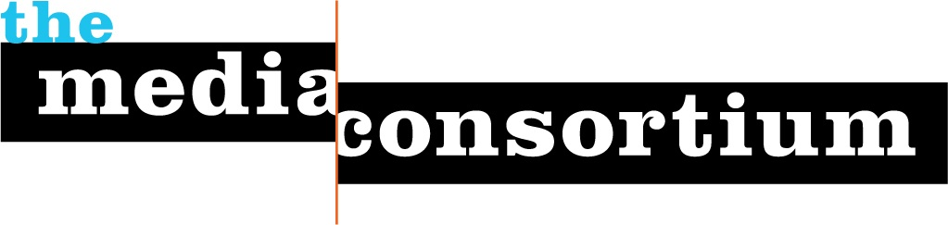
For Immediate Release: October 21, 2009

For More Information, contact:
Erin Polgreen, TMC Senior Program Associate
erin@themediaconsortium.com/ 312.841.0553
http://www.themediaconsortium.org/thebigthaw
Twitter: @tmcmedia, #thebigthaw

The Media Consortium, network of country’s leading
progressive media organizations, releases year-long study
The Big Thaw: Charting a New Course for Journalism
Lays out key recommendations, details implications of market trends on
journalism and business models, and provides special tools to use study

What form will journalism take in the future? Can independent media producers adapt and lead, or will they disappear with journalism’s Ice Age? As historical business and editorial structures melt away, a new study produced by The Media Consortium, reveals how independent media outlets and individual media-makers can thrive.

The Big Thaw was born out of a "game changer" strategy project initiated in 2008 by The Media Consortium, a network of the country’s leading, progressive media organizations, to support the evolution of independent media. The Big Thaw features:
- Detailed analysis of independent media’s competitive landscape and skills needed to succeed.
- Summary of market trends and implications for journalism & business models
- Strategy guide for media organizations
- Leading ideas and innovations
- Interviews with thought leaders: John Battelle (Federated Media), John Bracken (MacArthur Foundation), Amy Gahran (Poynter Institute), Jay Harris (Mother Jones), Larry Irving, (former Assist. Secretary, U.S. Dept. of Commerce), Vivian Schiller (NPR), Clay Shirky (NYU), Ashish Soni (USC), Don Tapscott (Wikinomics), Katrin Verclas (MobileActive) and David Weinberger (Harvard) and more.

The Big Thaw is broken up into a three-volume "box set."
  - Vol. 1: Dissonance & Opportunity: Summarizes and outlines a strategic framework that enables independent media to build a shared vision for the future.
  - Vol. 2: New & Emerging Realities: Four main questions are explored. How is the landscape changing? What new capabilities are needed to succeed? What needs can be met, problems solved or desires fulfilled to create value? How are media organizations structured to capture this value?
  - Vol. 3: The Future?: Surfaces key uncertainties to consider and future possibilities that may further change the game in coming years.

The Big Thaw’s website contains special tools for users including: a compilation of ideas for media makers on how use the report to enrich their own internal strategic planning, a list of "innovators to watch," and daily blog posts that will highlight key areas of the report over the course of a few weeks.
The Big Thaw also lays out four broad recommendations for independent media based upon year-long research:
- Change internally: New models will most likely come from new players. The first and deepest change is to rethink how media organizations and formal networks are structured. By integrating technologists, entrepreneurs and individual media-makers, independent media will cultivate new competencies and strategies to change the journalism field.
- Increase experimentation: Greater experimentation will win. Journalism organizations must increase their capacity to innovate with new technology, journalistic practices and business models. They can do this by pursuing “rapid, low-cost innovation” and pooling their experimental efforts. Experiments will range from mobile technology (e.g. location awareness) to new forms of visual storytelling (e.g. data visualization), convergence of content across multiple platforms, filtering of information and new ways of generating revenue and reducing costs. Funders must invest in the long-term sustainability of journalism’s truth-telling by investing in greater experimentation among both new and existing players.
- Leverage unique role of a consortium: Standing together will be more valuable than working alone. Since independent media will continue to grow more diverse and fragmented, it is critical that media-makers break out of organizational silos and work together. Media outlets are finding new ways to connect and collaborate with each other to share strategies, resources and editorial content. The more that independent media-makers leverage their collective power, the more they can negotiate deals, influence public policy and build journalism’s new ecosystem.
- Building audiences as communities: The product of journalism is no longer content, but community. It is not enough to talk about community or simply enable users to comment on stories. Media organizations must create platforms for users to participate in the journalistic process, work with each other on projects and build their own online communities independent of publishers.

About the author
Tony Deifell, president of Q Media Labs, has spent two decades as an entrepreneur, organizational strategist and media-maker.

About The Media Consortium
The Media Consortium is a network of over 40 leading, progressive, independent media outlets from print, radio, online, and television including Mother Jones, The Nation, AlterNet, Center for Independent Media, Link TV and more. It was formed four years ago to amplify independent media's voice, increase its collective clout, leverage current audiences and reach new ones, and last but not least, seize the moment to change the national debate. For the last five years, The Media Consortium has been on the front lines of the changing media landscape and is leading independent media outlets into a new era for journalism. (http://www.themediaconsortium.org)

