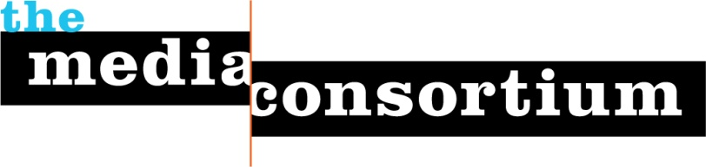
Support Independent Media!
Sponsor The Media Consortium’s Annual Meeting, October 13-14, 2011

Why SponsorThe Media Consortium?
The Media Consortium is the only organization that represents this country’s leading independent media outlets—outlets including AlterNet, LinkTV, Mother Jones, The Nation, Brave New Films, Grist.org, and Democracy Now! Collectively, our outlets reach an audience of over 30 million. Agile and innovative, Consortium outlets seek cutting-edge technologies to better reach their dedicated audiences. And don’t forget—as independents, Consortium outlets share the values of experimentation, originality, and media freedom that shaped Silicon Valley culture.

Why Sponsor the Media Consortium’s Annual Meeting
The Consortium’s annual meeting brings together all 50 of our outlets in a small conference center for an intense two days of networking and learning. The small size of this meeting is its value—outlets send their leadership, so as a sponsor you reach decision-makers directly. As a sponsor you will:
- Reach media decision-makers directly;
- Have the opportunity to network in person with media makers;
- Enhance your corporate image by supporting the entire sector of the independent media;

Sponsorship Opportunities
- Independent Media Sponsor: $5000
  - Large, visible signage in meeting room
  - Thanks from podium at opening, public forum, and closing
  - 2 people of your choice may attend all day October 13
  - Mention on all print/digital materials
- Media Training Sponsor: $2500
  - Large, visible signage during media training presentation
  - Thanks from podium at opening and closingn of the meeting
  - 2 people of your choice may attend all day October 13
  - Mention on all print/digital materials
- Lightning Presentation Sponsor: $2500
  - Large, visible signage during lightning presentation
  - Thanks from podium at opening of presentations
  - 2 people of your choice may attend all day October 13
  - Mention on all print/digital materials
- Meal Sponsor: $1000 for lunch; $500 for breakfast
  - Large, visible signage during meal
  - Thanks from podium before/after meal
  - 2 people of your choice may attend all day October 13
  - Mention on all print/digital materials
- Scholarship Sponsor: $250-$2500
Contact us to work out details.

Yes, I want to Learn More--Whom Do I Contact?
Please contact Jo Ellen Green Kaiser at joellen@themediaconsortium.com or 415-878-3862 to learn more about sponsorship opportunities.

