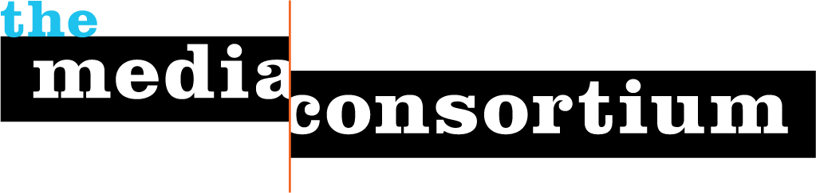

December 29, 2009

Mr. Geoffrey Sands
McKinsey & Company
55 East 52nd Street
New York, NY 10055

Dear Mr. Sands,

Since you are a leader in shaping the media business, I wanted to share with you a copy of The Big Thaw, a major study we published this fall about the future of independent media. The Media Consortium worked with one of the leading thinkers about the new media landscape to produce this report.

The Media Consortium is a group of 45 of the country's leading independent media organizations including Mother Jones, The Nation, Link TV and Salon.com. We published this report to help independent media organizations thrive in the new media landscape by thinking and acting strategically.

As you can see from the review by the Free Press, The Big Thaw has already become well regarded as a resource in the field of journalism. It was also listed by John Bracken of the MacArthur Foundation in his list of "2009’s Most Influential Media About Media."

The tidal waves that hit print journalism in 2009 are likely to affect TV, film and gaming in 2010 and beyond. We believe that through collaboration, independent media organization can chart a new future together.

Feel free to share this resource with others. You can find a PDF copy online at www.themediaconsortium.org/thebigthaw

Sincerely,

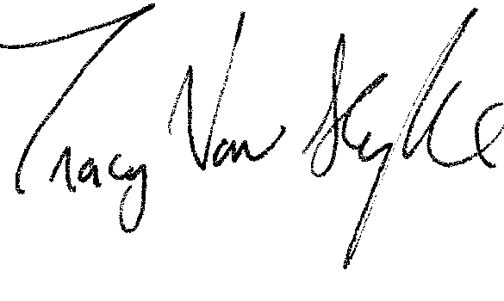
Tracy Van Slyke
Director, The Media Consortium

