Q&A’s for audience
- How many here are with foundations?
- How many here are investors or represent venture capitalists?
- How many here consider yourself media producers?
- Who here has a blog? Tweets?

Major Takeaway:
Investment in a few major areas:
- Experimentation: So fundamental
- Reporting + community engagement models
- Staffing: training for more robust understanding of how to operate in online environment and more technology//programmers to help build more collaborative

In fall 2009, The Media Consortium completed a year-long study that was born out of a desire to change the game for media consortium members and help us become the shapers of tomorrow’s media—moving from an organization that provides support in a crisis to one that helps members lead in the future.
As traditional business and editorial models melt away, new innovations are rapidly reforming journalism. As traditional business and editorial models melt away, new innovations are rapidly reforming journalism. The question is (CLICK).

Can media producers adapt and lead, or will they disappear as we move out of journalism’s Ice Age?

In The Big Thaw, we lay out four interlocked areas that we must navigate through as we look to identify how to evolve in this new environment.
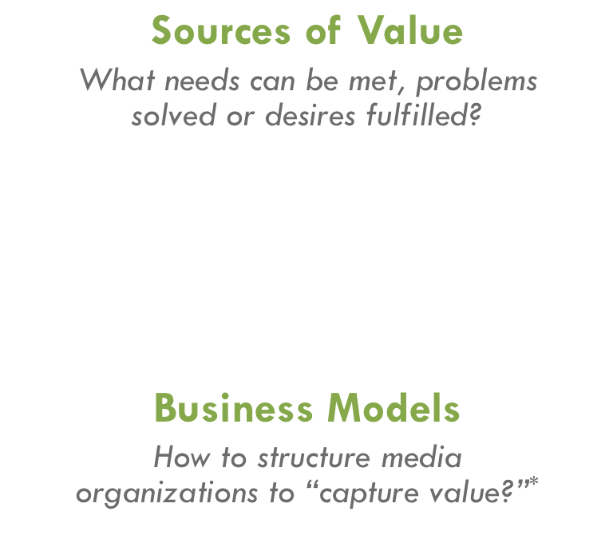

The Big Thaw had 4 major recommendations:

Launch of II Labs:
Small group labs
Research, collaboration, talking to experts, seed money
Within the Digital Innovation Studio, The Media Consortium has recruited over a dozen media organizations to participate in one or more of the following labs.
- Moving into mobile: Cell phones, e-readers, and iPads, oh my!
- Integrating journalism with community engagement and building models
- Experimenting with new revenue-generating opportunities

With these small-group labs, The Media Consortium's goals are to support deep learning and incremental shifts for TMC members to develop new models for revenue generation, audience development, and editorial content. Cumulatively, these labs will catalyze a broad shift in how independent media outlets survive and thrive in a 21st century landscape. In addition to organizing the labs, The Media Consortium is providing seed money to help incubate a collaborative experiment for each lab.
Experiment criteria:
- Have top line goal(s) that can be shared by all participants in that small group lab.
- Address one or more of following opportunities:
  - Bring in revenue from new sources or deepening current revenue-generating opportunities;
  - Raise impact/influence of journalism (i.e. collaborations, new journalism production models, community engagement);
  - Expand reach of content to targeted audiences.
- Be scalable/replicable.
- An emphasis on experiments that are collaborative or customizable per organization is highly encouraged.

