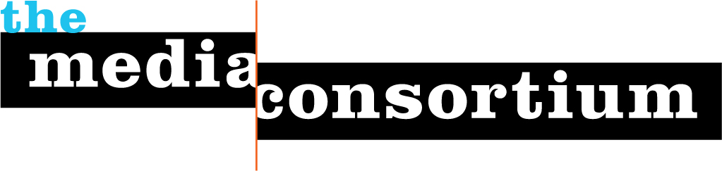

Project Proposal to the Chicago Community Trust
Collaborative Storytelling Project for On The Table 2017
Revised March 24, 2017 *

- Executive Summary

The Media Consortium is a 501c3 network of independent and community media outlets dedicated to values-driven journalism. Founded in 2006, the Media Consortium grows the impact of member organizations through collaborations and partnerships that cross-pollinate communities with critically important stories.

Our Who Counts project in 2016 centered on reporting on immigrants, including a briefing that was attended by over 20 Chicago-based outlets. In February 2017, seven community-based Chicago outlets traveled to DC to participate in the Media Consortium’s annual meeting (thanks to generous support from MacArthur). We look forward to continuing and developing a strong network of Chicago-based community media.

- Scope of Work

The three objectives of this work will be:
- to foster new and substantive relationships among media outlets that serve different communities within Chicago;
- to support development of a local media network for collaborative storytelling that provides more complete stories of Chicago’s neighborhoods;
- and to expand the civic conversation nurtured at On the Table by helping to communicate the impact of those conversations in specific communities and neighborhoods.

This project is comprised of these components:

- Recruit 12-15 Chicago-based media platforms, focusing particularly on outlets engaged with self-identified communities, (e.g. Latino, African American, Chinese, LGBTQ, youth) to tell stories that better capture the breadth of On the Table conversations.
- Gather senior leadership from these outlets for an in-person meeting on Thursday, March 16 to provide a briefing about On the Table; to determine if the outlet is willing to participate in an On the Table event; and to obtain firm commitments from the outlets on how they will engage in this collaborative effort.
- Provide these outlets with a Media Consortium membership and connect them with Chicago-based Media Consortium members to provide additional storytelling support.
- Manage logistical coordination with all participating journalists and storytellers to host at least 7 OTT events. Ensure outlets are fulfilling their commitments to produce stories.
- Host a post-project meeting with participating outlets to evaluate their experience, and determine ways they can work together moving forward.
- Provide a final two-page report detailing which outlets participated, and whether they hosted or otherwise engaged directly in On the Table events; a listing of stories produced; and an analysis of the impact of outlet storytelling on the wider perception of On the Table in the communities these outlets serve.

Please note: A core value of the Media Consortium is truth-telling. We will not dictate nor change the direction of a story, nor ask outlets to pull stories that are unfavorable to our funders.

- Timeline

Kick-off phone meeting with media outlets: March 14

Project meeting with participating media: March 16

Coordination and Story Production March 27-May 12
-produce 5-7 stories pre OTT 2017

On the Table Events May 16
-host at least 7 OTT 2017 events (some will be collaborations)

Coordination and Story Production May 17-June 16
-produce 8-10 stories post OTT 2017

Post Project Meeting June 16, 2017

Produce Report June 30, 2017

- Funding Request

Our total funding request is: $20,000

Project Manager (4 months): $9000
Story production costs (12 outlets): $8400
Media Consortium Memberships (12 outlets @ $75/outlet): $900
Grant Bookkeeping and Reporting: $1700

Payment Schedule
March 31: $6700
May 7: $6700
June 16: $6600

- Team Background

The project lead for the On the Table reporting project will be the Media Consortium’s Associate Director, Manolia Charlotin. Deeply familiar with Chicago’s ethnic communities, Manolia is herself an immigrant of Haitian descent who speaks five languages. As a journalist who has led 3 community media outlets, Manolia understands the desire of these journalists and storytellers to tell the truth of their communities, and knows how to support them in their work. She has lead numerous collaborative media efforts, including 35 reporting collaborations among 40 of TMC members for our Metrics Project (with generous support from Voqal).

*Revised Addendum to original Scope of Work submitted on March 10, 2017

