# Executive Summary

**PHOTO**

**This page has limited text so the designer can make a transition page here using a large photo. Example of great transition pages:**

[http://digitaloutlook.razorfish.com/publication/?i=13617](http://digitaloutlook.razorfish.com/publication/?i=13617" \t "_blank)

The photo can take the whole page,   
I just have this here as a place marker.

“No society in history has ever existed without storytelling. The job of storytelling is to tell stories that are true and important. Sure, there may be many distinctions between professionals and amateurs, between breaking news and follow up pieces, between long or short, and so forth. But these are just artifacts of production methods rather than deep truths. And we have to have truth tellers.”

*– Clay Shirky*

Journalists and independent media-makers will continue to be society’s most valuable truth tellers. However, the old media system that historically supported them is melting away. Some outlets have succumbed to the “big thaw” of the old system by shutting down or drastically cutting news operations. Others have made small changes to their journalism and business models that keep them afloat one more day.

*The Big Thaw: Charting a New Future for Journalism* focuses on how independent media organizations can navigate the currents of change to reach higher ground over the long term.

“While changes to the news industry advanced at a glacial pace for many years, [...] transition can come as quickly as the levees that broke in New Orleans. Trigger events cause sudden floods before a new system is in place to prevent it. News organizations are facing flash floods and many are in a mode akin to sudden-death, wilderness survival. Laurence Gonzalez, in his book, *Deep Survival: Who Lives, Who Dies, and Why*, explained that those people who most quickly surrender to their new circumstances, take decisive action, and believe anything is possible are the ones most likely to survive. Each independent media organization must answer two questions in order to survive, '**What will you be standing on when the flood reaches you?**' and '**How will you boldly move to higher ground?**’”

*– The Big Thaw, Vol. 1, p4*

Although many see this moment as a meltdown, it is an opportunity. Much like the annual flooding of the Nile, it has the potential to revitalize the landscape. The nature of how we use information is changing, and great opportunities lie ahead.

* Mobile devices are transforming our relationships with people, events and place.
* Everyone can gather, share and produce news.
* U.S. demographics and global audiences are revolutionizing the media marketplace.
* New types of media-makers are emerging, who are pursuing journalism’s public-service aim in brand new ways.

Between 2008-09, The Media Consortium (TMC), a network of 45 leading independent media organizations, conducted a *Game Changer Strategy Project* that resulted in this report. A broad array of information was collected via scenario building, member surveys, interviews with outside thought-leaders and a scan of current reporting and commentary. The project’s goal was to enable TMC and its members to make bold moves that increase their impact and influence by reaching five times their current collective audience within the next five years. A proxy for TMC’s collective online reach as of June 2009 was 17 million monthly website visits. The collective constituency lists of its members surpasses 2.9 million.

* [Appendix A](#Appendix_A)  
  List of Participants

**The Media Consortium  
Mission Statement:**

To amplify our voices; increase our collective clout; leverage our current audiences and reach out to new ones; attract financial resources; strengthen and transform our individual businesses and our sector’s position in a rapidly changing media and political environment; and redefine ourselves and progressivism for a new century.

For decades, progressive media has provided quality reporting, deep investigative journalism and lifted voices ignored by mainstream media. While journalists cannot preserve the old media system, with the correct strategy and implementation, they can deepen their legacy of truth-telling and fighting for justice.

**New & Emerging Realities** | Volume 2

This volume examines the most important realities of the new media landscape. Four strategic questions frame the new challenges and opportunities for media organizations (outlined in the diagram below).

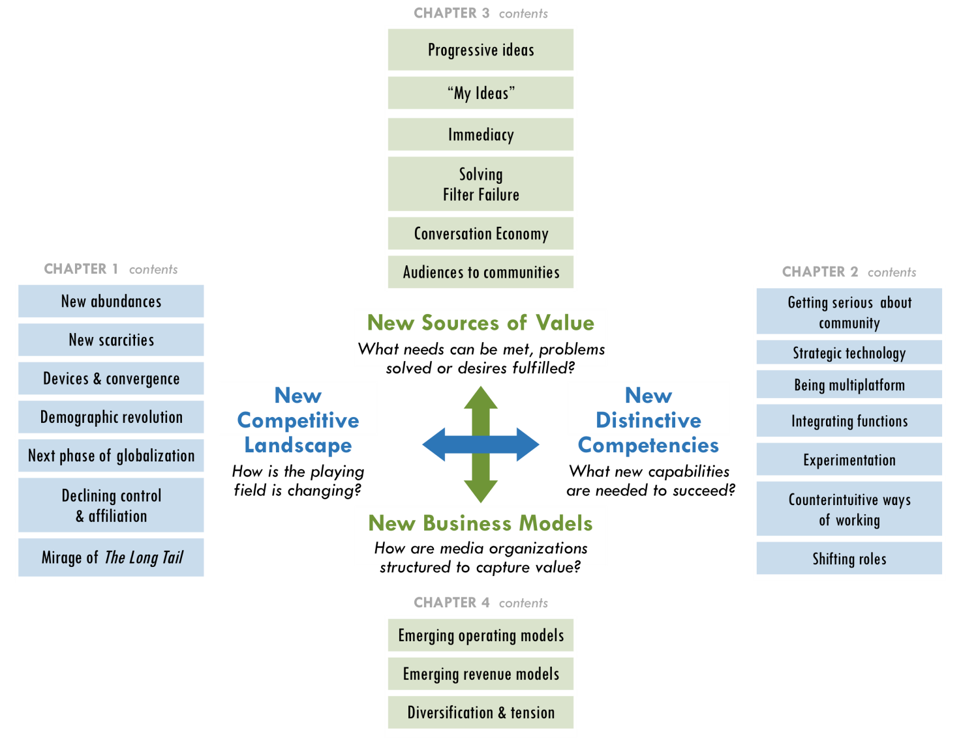

* New ***Sources of Value*** will create new ***Business Models***. Traditional business models, based on the value created between publishers and readers, have declined for a decade. The world economic crisis accelerated this meltdown, and organizations have redoubled efforts to find new sources of value and cut costs.
* Organizations’ ***Distinctive Competencies*** must match media’s new ***Competitive Landscape.*** In the new environment, collective action by a consortium of organizations has great potential to increase the power of independent media. However, bold collective steps will require a shared perspective about media’s new realities their implications.

**The Future?** | Volume 3

Many uncertainties and opportunities remain on the horizon.

* Industry leaders are unsure how consumers will act, which trends will last, whether online media is helping or hurting our democracy and how the biggest players will affect the game.

The rule of thumb is to *expect the unexpected*. Radical changes in technology will continue to affect the competitive landscape and the [new competencies](#_CHAPTER_2_NEW_1) outlined in Vol. 2 will become even more important.

* Independent media-makers must keep their eye on game changers to come (diagram below). Most of these trends are in their early stages. While they have yet to reach game-changing scale, many of them will.

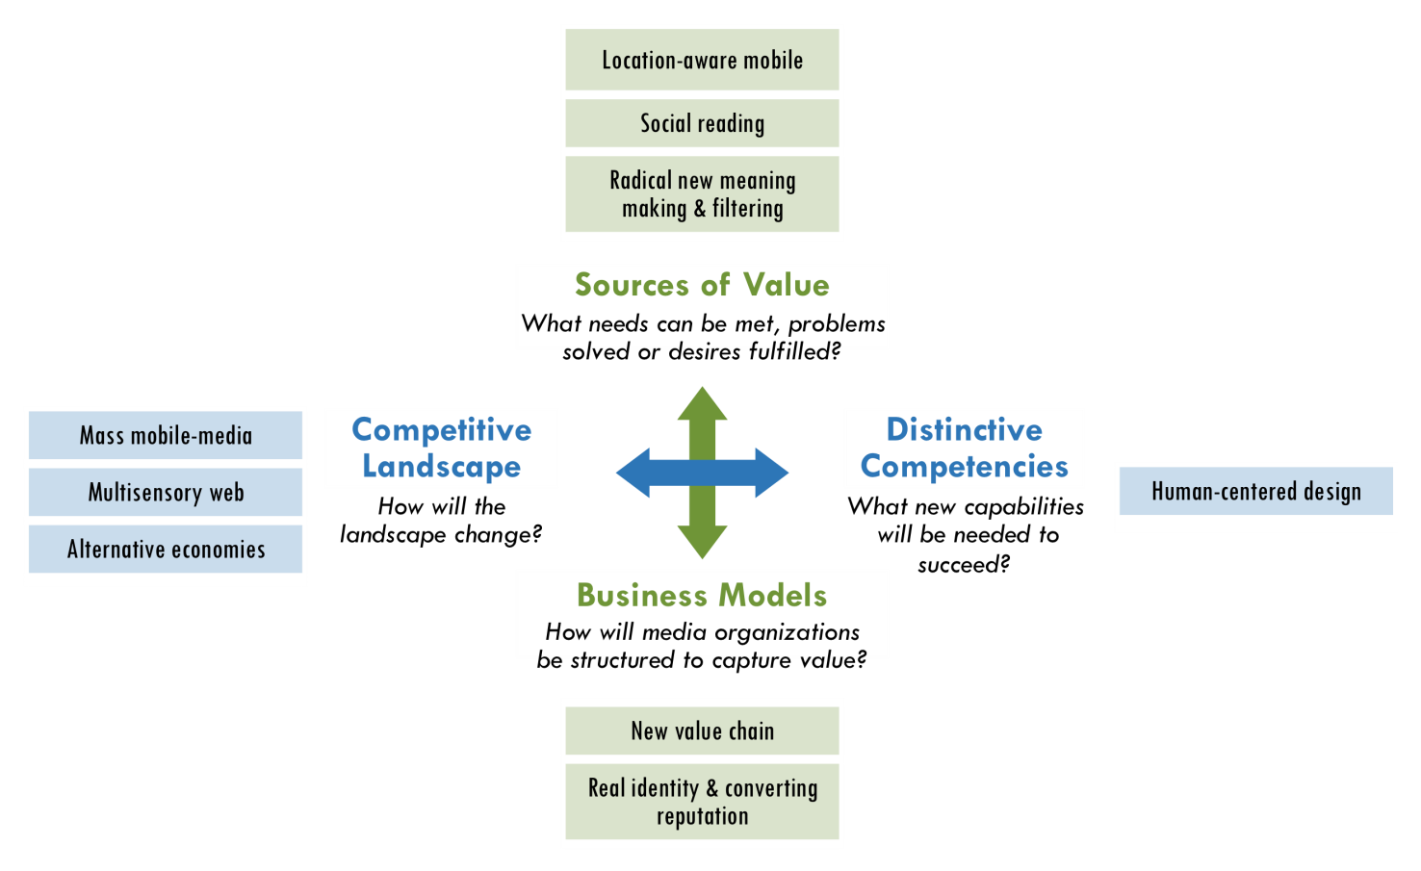

**Recommendations**

The Media Consortium, other media networks and individual independent media organizations can take advantage of emerging and future industry conditions by making four decisive moves:

1. Change internally

***New models will most likely come from new players.*** The first and deepest change is to rethink how media organizations and formal networks (such as TMC) are structured. By integrating technologists, entrepreneurs and individual media-makers, independent media will cultivate new competencies and strategies to change the journalism field.

1. Increase experimentation

***Greater experimentation will win.*** Journalism organizations must increase their capacity to innovate with new technology, journalistic practices and business models. They can do this by pursuing “rapid, low-cost innovation” and pooling their experimental efforts. Experiments will range from mobile technology (e.g. location awareness) to new forms of visual storytelling (e.g. data visualization), convergence of content across multiple platforms, filtering of information and new ways of generating revenue and reducing costs. Funders must invest in the long-term sustainability of journalism’s truth-telling by investing in greater experimentation among both new and existing players.

1. Leverage unique role of a consortium

***Standing together will be more valuable than working alone.*** Since independent media will continue to grow more diverse and fragmented, it is critical that media-makers break out of organizational silos and work together. Media outlets are finding new ways to connect and collaborate with each other to share strategies, resources and editorial content. The more that TMC members leverage their collective power, the more they can negotiate deals, influence public policy and build journalism’s new ecosystem.

1. Building audiences as communities

***The product of journalism is no longer content, but community.*** It is not enough to talk about community or simply enable users to comment on stories. Media organizations must create platforms for users to participate in the journalistic process, work with each other on projects and build their own online communities independent of publishers.

***Decentralized communities will have the greatest impact.*** Media consumers have more power than ever before. They will be attracted to the most user-focused media ventures. Media organizations will grow their audiences by building deeper communities while also reaching broader networks. People today are less tied to formal institutions, and they increasingly affiliate with decentralized networks of individuals and groups. As a result, TMC members can not only reach broader domestic and global audiences by collaborating, but they can also engage those audiences more effectively by tapping users’ full potential as producers, community builders and agents of social change.

**What if?** | New strategic intent for Independent Media

Most people assume that the future is something to be predicted rather than created. The future does not simply happen to us; we shape it.[[1]](#endnote-1) TMC members and other independent media organizations can use the four recommendations above to ask “What if?” Together, we can imagine a future we want to create. *The Big Thaw* is a guide to chart the course.

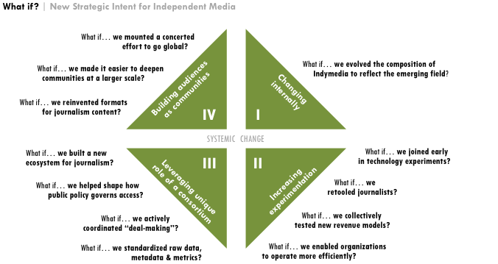

*The research and analysis for this report led to 16 recommended project ideas for TMC and its members, which will be used internally. For more information, please contact TMC Project Director Tracy Van Slyke at tracy@themediaconsortium.com.*

1. Donella H. Meadows, *The global citizen*, Island Press, 1991, p4 [↑](#endnote-ref-1)