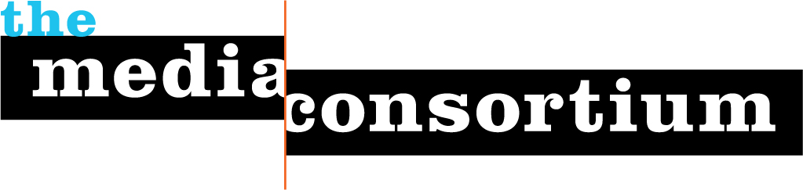

You are Invited to the 8th Annual Media Consortium Meeting
Making Impact
February 6-8, Baltimore, MD

February 6 Pre-Meeting: The Power of Print
- Guest Speakers: Print industry guru Bo Sacks and Bob Cohn, editor of Atlantic Digital
- Panels on To Stay or not to Stay (in Print), Making Newsstand Work, Marketing to Subscribers, and Tablet Strategy for Print Publications

February 7-8: Making Impact
- Plenary Speakers: Former FCC Commissioner Michael Copps and Amy Mitchell, Deputy Director of Pew’s PEJ program
- Sessions on Creating a Multiplatform Campaign, Tools for Online Donors, Package that Content!, Hybrid Business Models, and more!
- Plus: plenty of open time to connect with Media Consortium members, including publishers and editors from Mother Jones, The American Prospect, Truthout, LinkTV, Yes!, Dissent, and the Nation.

Where: The Wyndham Peabody Hotel, located in the cultural and civic center of Baltimore. Act now to reserve your $109 room (includes wireless and breakfast—scroll down and click the second “reserve” button)!

Who: The Media Consortium is a national network of independent news outlets.

How: For the first time this year, The Media Consortium is opening its annual meeting to non-members. To register, please fill out this form. Conference fees for non-members are $250/outlet, which includes lunch Feb 6 & 7 and registration for two staffers. The public part of this meeting ends at noon February 8.

Why: The Media Consortium’s annual meeting offers an opportunity for peer-to-peer networking you can find nowhere else. If you’d like more information, contact Executive Director Jo Ellen Green Kaiser at joellen@themediaconsortium.org

