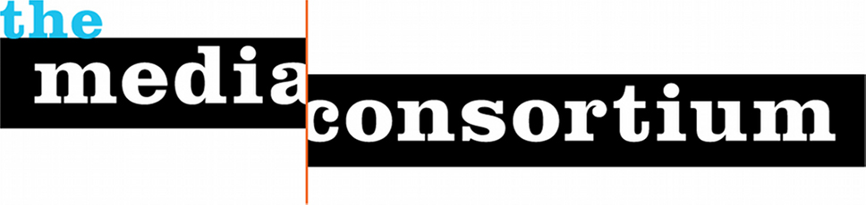

Who is the Media Consortium?

The Media Consortium (https://themediaconsortium.org) is a non-profit North American network of over 80 independent national news outlets, collectively reaching over 100 million people a day. Our member outlets are multiplatform—online, in print, and on the air. Prominent members include Mother Jones, The Nation, Democracy Now!, Orion, Ms. Magazine, AlterNet and Grist.

Why Sponsor the 2017 Transformative Media Conference March 1-4 in DC?

The Trump era poses significant real threats to our democracy and to the news media. The flip side is that the Trump era offers opportunities—especially to independent newsmedia--to transform the news media system to better reflect democratic values. The goal of this conference is to realize that opportunity.

Having functioned as outsiders, independents are better equipped than “mainstream media” to question the powerful. And unlike corporate news outlets, independent, values-driven, mission-based outlets have the trust of their audience and community.

To tranform themselves from “alternative news” to the real news people seek, independents will need to double down on the values of inclusivity and equity as well as the journalistic values of accuracy and accountability. The challenge for independent news is to live up to its own mission to put communities (rather than journalists or politicians) at its center.
The specific objectives of this conference are:
1) Develop concrete ways to further editorial collaboration between news media working with and within different communities;

2) Develop concrete ways to for news outlets to collaborate on new means for distribution, marketing, and promoting content;

3) Renew Media Consortium members’ commitment to racial, geographic and class equity within our organizations.

Sponsorship Opportunities
Lunch: $7500 (2)
Host lunch on Thursday March 2 or Friday March 3, 2017
- Opportunity to make a brief announcement before 125 attendees
- Opportunity to distribute branded materials on tables
- Opportunity to host a table in our exhibit area
- 2 full conference registrations
- Onsite signage
- Logo and link prominently placed on conference website

Badges and Registration Desk: $3,000
Dedicated branding and handouts (provided by Sponsor) at registration area.
- Sponsor Logo on all attendee badges
- Opportunity to host a table in our exhibit area
- 2 full conference registrations
- Onsite signage
- Logo and link prominently placed on conference website

Snack and Coffee Break: $2,500 (2)
Host a refreshment break in the afternoon. Sponsor logo displayed on refreshment table.
- Opportunity to host a table in our exhibit area
- 2 full conference registrations
- Onsite signage
- Logo and link prominently placed on conference website

AM Coffee Break : $750 (2)
Host a coffee break in the morning. Sponsor logo displayed on refreshment table.
- Opportunity to host a table in our exhibit area
- 2 full conference registrations
- Onsite signage
- Logo and link prominently placed on conference website

Sponsor a Journalist: $1200/journalist
Hotel: $179/night * 3 nights = $537 + $77 tax = $615
Registration: $150 (special member rate includes lunch)
Airfare: $500 on average

Ask us also about sponsoring our opening reception Wednesday evening, March 1.

Contact: Jo Ellen Green Kaiser
joellen@themediaconsortium.org
415.878.3862 | @tmcmedia
Conference Site: http://tmcmedia.org

