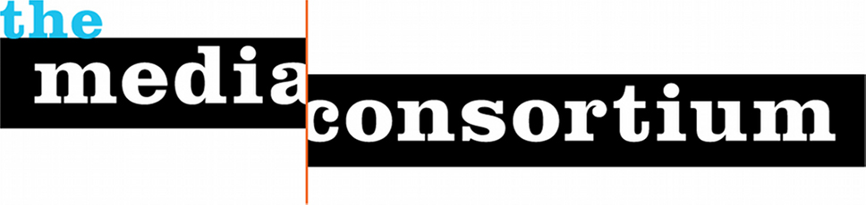

TMC 2017 Transformative Media Conference

Goal
Independent news media are the first defenders of free speech in the Trump Era. Our mission—to tell the truth, to be the voice of dissent, to be the conscience of the nation—is critically important. When the public has lost trust in corporate news, ours if the trusted voice.

At this moment, to serve the public, we must transform how we see ourselves. No longer merely the "alternative" to mainstream media, can we start seeing ourselves as the most trusted and valued news outlets in the nation? Can we seize the opportunity to transform our media system?

Yes we can. We believe there is an opportunity with the failure of corporate media to create a new media system that is mission-based and values-driven. Among the values this new media system will share will be the journalistic values of accuracy and accountability, and the social values of inclusivity and equity. It will be a news media that puts communities (rather than journalists or politicians, etc..) at its center. Our democratic values are at stake. We must seize the moment to ensure the voice of all the people is heard by those who govern.

Top Objectives
1) Develop concrete ways to further editorial collaboration
Independent news outlets own niches. In order for them to transform the media system, they will need to work together. We have spent the past five years at the Media Consortium creating a collaborative culture, but what has gotten in the way are logistics--the fact that collaboration costs money. We need fresh thinking on how we can either get the money or make the processes easier.

2) Develop concrete ways to collaborate on marketing/promotion/distribution
In order to transform the media system, our members must be able to "show up" on the radar of influencers and the public. We need fresh thinking on how to get our content into the larger marketplace.

3) Renew our commitment to racial, geographic and class equity within our organizations
Last year, we devoted our conference to racial equity, with a full-day workshop led by Race Forward. Over 65 individuals attended that workshop--about half of all attendees at the conference. We need to continue to emphasize that we will not be living our values unless all our outlets are racially equitable. And this election demonstrates that we must also be geographically equitable. We need a renewed commitment to these values.

Method
One of the key values in independent media is centering community. Thus, to move forward on transforming the media ecosystem we will begin by centering the voices of the members of the independent media community.
The heart of this conference will be open space self-organized conversations on Thursday and Friday facilitated by Chris Michael.

A plenary conversation on Wednesday evening will provide us with energy and momentum to begin these conversations on Thursday; a pause on Friday morning with the more formal panel discussion structure will focus conversations. Because we want to come up with solutions, we are inviting a number of vendors and experts to bring their solutions into our space on Friday afternoon. We anticipate groups may visit with these vendors or invite them into their spaces.

We will end this part of our conference on Friday evening with commitments. Saturday is dedicated to providing Media Consortium members with content they need for the next year, although it is possible—and welcome--that some groups from Friday may want to continue meeting Saturday.

Where We Need Support

Travel Expenses for Journalists of Color

Last year, we made a strategic commitment to racial equity within the Media Consortium, which to us means that we want to have at least a 50% representation of people of color as speakers and participants in our conference. We have found, however, that outlets that are primarily staffed with journalists of color are often the least able to cover travel expenses to our conference.

Travel, hotel and meals cost anywhere from $750-$1250 for journalists depending on their origin point. The Media Consortium does not have the budget to cover these expenses, so we seek travel scholarships for them.

Ask: $10,000 for travel scholarships for ten $1,000 direct grants to 10 attendees. You, of course can choose these attendees and/or we can work with you throughout this process to ensure grantees are demographically and geographically diverse.

Facilitator Cost

In order to achieve the goals we set, we decided to turn our conference into an open space gathering focused on: 1) addressing the threats we face and; 2) developing practical means to grasp the opportunities available.
To make open space work with journalists, we had to hire an excellent facilitator. We found one in Chris Michael. Chris was highly recommended to us by Allen (Gunnar) Gunn and Deanna van Zandt. He has a history of working with media organizations including Witness and Air, and he's also facilitated for Open Society Foundation and Ushahidi. We are lucky to have him--and will be even more fortunate, frankly, if we can find a way to pay for him.

Ask: Help us defray the facilitator cost by providing a $5000 grant to TMC. This would help cover additional registration costs for diverse journalists and a coffee break that supports the flow of this type of facilitated conversation.
We incur these costs because we provide our members a 50% discount over the real costs of holding the conference, given that they’re running tight ships in this difficult moment. So your sponsorship actually makes it possible for our members to attend as well.

