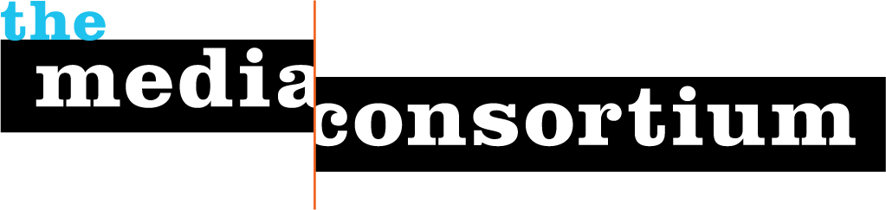

Current Consortium Members
Last updated: December 2, 2007
43 total members.

Afro-Netizen
Air America Radio
Alternet
Balcony Films
Berrett-Koehler Publishers
Brave New Films
Chelsea Green Publishers
ColorLines
Democracy Now
Free Speech TV
GlobalVision/Media Channel
GoLeftTV
Grist
Hightower Lowdown
In These Times
LinkTV
Media Venture Collective
Mother Jones
Moving Ideas, a project of Care2
Ms. Magazine
Nation Institute
NAMAC
National Radio Project
New America Media
New Press
Public News Service
Raw Story
RH Reality Check
RealTV/IWT
Salon Media Group, Inc.
Sojourners
South End Press
Talking Points Memo
The American Prospect
The Nation
The Progressive
The Washington Monthly
The Young Turks
Truthdig
Warandpiece
Women's Media Center
Workers Independent News
YES! Magazine

