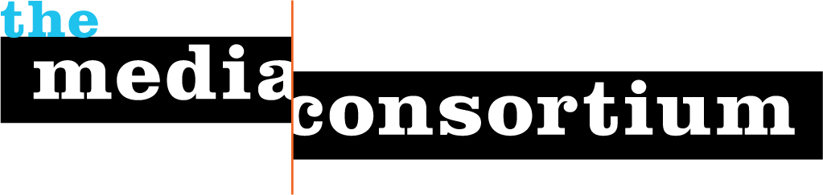
Membership Screening Questionnaire
Any information gathered during this process is for private consideration by the Media Consortium's membership committee and will not be released without the permission of the organization applying for membership.
These questions help us determine suitability for membership, and help us set dues:
- What is your organization’s mission and vision?
New Labor Forum is a national labor journal from the Murphy Institute at the City University of New York. Published three times a year, the journal provides a place for labor and its allies to test and debate new ideas. Established in 1997 in the wake of the historic, contested elections at the AFL-CIO, the journal has sought to make use of the space created by the ensuing rapprochement between labor leaders, left intellectuals, and community-based activists. During nearly two decades of publication, New Labor Forum has provoked debate and informed discussion on the most crucial challenges confronting workers, working-class communities, and organized labor. We publish the work of national and international scholars, journalists, and labor activists.
Issues we explore include (but are not limited to): the global economy’s impact on work and labor; new union organizing and political strategies; labor’s diverse constituencies and their relationship to organized labor’s traditional institutions; internal union reform and new structural models for the labor movement; alternative economic and social policies; and the role of culture in social movements. Our core constituency consists of labor leaders, activists and scholars, as well as community-based activists concerned with the “labor question” broadly conceived.
- Why do you want to join The Media Consortium?
- Our staff is interested in learning from and sharing experiences with other progressive outlets that aim to publish thoughtful, high-impact work
- We have a pressing desire to better understand and use new platforms for communication with our subscribers and potential subscribers, visibility our overall and engage more broadly in conversations regarding the issues we deal with
- Does your organization have any areas of expertise that could be helpful to The Media Consortium and its members?
Our very deep and broad expertise on organized labor, Alt-labor, social class, and the “labor question” writ large should prove useful to consortium members.
- What is your operating budget?
This is a tough question to answer, since we operate in the red. SAGE Press, our publisher, offers us a very small editorial stipend only. CUNY pays the salaries for our entire editorial staff: Editor, Editor-at-Large, and the Managing Editor.
- How many staff do you have? Editor, Editor-at-Large, and the Managing Editor (12 hours per week), Marketing Director (began November 23, 2015 and works 12 hours per week)
- Would you like to join as an associate or full member? Full member

Answering the following questions will help us better serve you as members:
- Are you organized as a non-profit or a for-profit? Non-profit
- How would you describe your primary audience in terms of size, diversity/demographics, lifestyle and geography?
Our primary audience consists of labor activists and leaders; community-based activists concerned at least in part with class issues; scholars broadly interested in organized labor and social class; and international trade unionists
- What are your primary platforms? (e.g., print, radio, online, video, tv, books, social networks, etc.)
We publish a print journal (roughly 130 pages) three times per year, and are just beginning an emailed newsletter to go out twice a month.
- What infrastructure is your organization looking to build? (e.g., advertising, web strategies, technological innovations, editorial planning, etc.)
We’re looking to increase our visibility and impact on-line, and explore web strategies and advertising possibilities.
- Who will be the primary TMC contacts for your organization? (We recommend one editorial contact and one business contact.) These representatives will be expected to attend TMC meetings, convey pertinent information regarding our projects to your staff, and ensure that your organization is involved in TMC-related projects and conversations.
Paula Finn, Editor: Paula.Finn@cuny.edu
Charles Lenchner, Marketing Director: clenchner@organizing20.org

Please return this questionnaire to Jo Ellen Green Kaiser at joellen@themediaconsortium.com.

