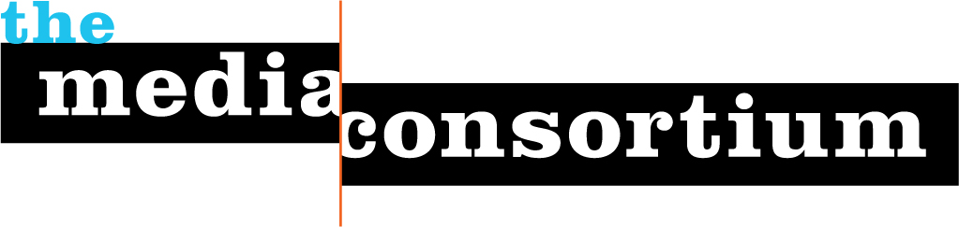

May 10, 2017

Dear Deonna,

Congratulations! You have received a $1000 grant to participate in the Media Consortium’s New Economies Project.

Please follow the next steps to receive your grant and start the project:

1. Fill out and sign the attached agreement.

2. Send us an invoice for $1000.

3. Send us a W-9 (blank attached). Please do not forget to fill out the W-9 with your (or your organization’s) legal name, address, and EIN/SSN, and please remember to sign the W-9!

4. The reporter on this project will be added to a google group. If someone else from your organization also wants to be added to the google group, send an email to new-economies-project@googlegroups.com

The first webinar for this project will take place in mid-June. You will receive a date from us shortly.

Congratulations again!

Sincerely,

Jo Ellen Green Kaiser
Executive Director, The Media Consortium
joellen@themediaconsortium.org
415-878-3862

