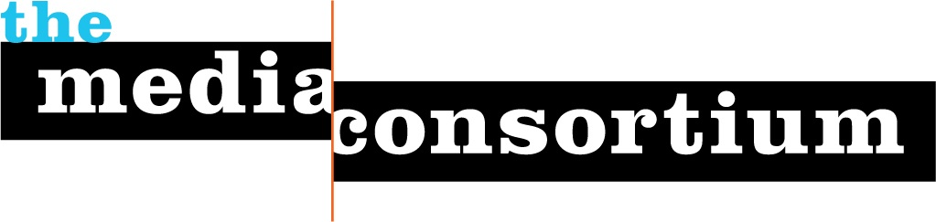

January 11, 2009

Dear Ms. Moran,

The Media Consortium, a network of the leading independent, progressive media companies (including The Nation, Mother Jones, Talking Points Memo, AlterNet, Ms. Magazine, The Center for Independent Media, Brave New Films, Free Speech TV and some 40 more) would like to invite you to speak at a special meeting of The Consortium on either February 10 or 11, 2009 in Washington, DC. Our meeting will be held at the Washington Parks and People at 2437 15th Street, NW.

The members of The Media Consortium have a combined audience of more than 10 million active readers/listeners/viewers who rely on our media to stay informed about matters of the public interest. The majority of these individuals are actively engaged in the strengthening of their communities and our country. They also have a vested interest in the success of the Obama administration. We believe, and hope you do as well, that it would be productive to establish a direct relationship between the communication office of the Obama White House and the editors and management of this influential media network.

We hope you can join us for a special session on February 10 or 11. Our initial thought for the session is that it would be very useful for us to hear directly about the priorities of the Obama administration during its first year and your candid assessment of the political and communication challenges -- remarks plus a Q&A session. As we have our schedule tentatively drafted, the ideal time slots for us would be from 9:30 to 11 a.m. or 11 a.m. to 12:30 p.m. on February 10, but we can certainly adjust to another time during those two days if that would be make this more feasible for your schedule.

You can learn more about The Media Consortium, its members and activities, at www.themediaconsortium.org. To confirm or to discuss this further, please feel free to email or call The Media Consortium’s Project Director, Tracy Van Slyke at 312-315-1127 or tracy@themediaconsortium.com or Mother Jones’ Publisher Jay Harris at 415-902-8511 or harris@motherjones.com.

Best Regards,

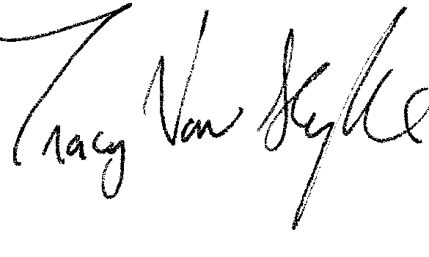
Tracy Van Slyke
Project Director
The Media Consortium
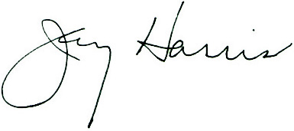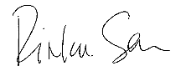
Jay Harris Rinku Sen
President and Publisher, Mother Jones Publisher, ColorLines
The Media Consortium Co-Chair The Media Consortium Co-Chair

