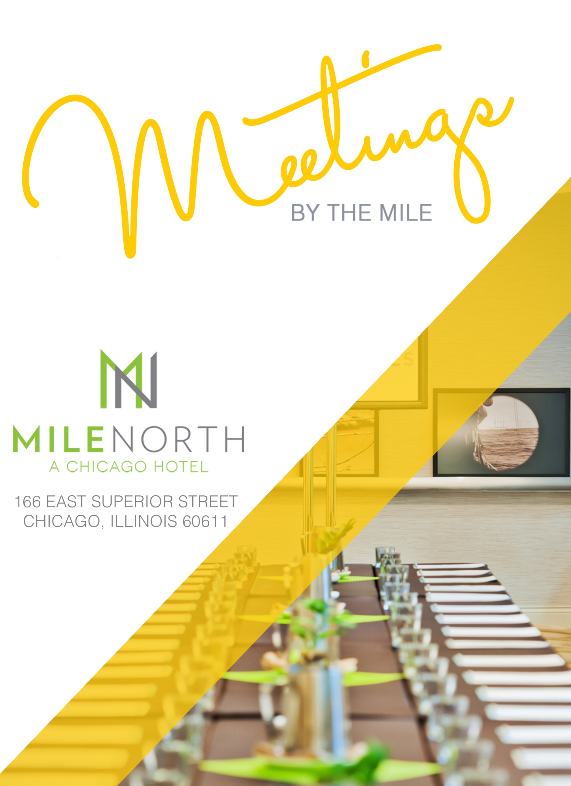

BREAKFAST
served for up to 90 minutes

Continental Breakfast | $30.00 per person
for 10 guests or more
Orange juice and grapefruit juice
Fresh-baked assorted Danishes, croissants, bagels and muffins
Fruit preserves, cream cheese and butter
Starbucks coffee and hot Tazo tea service

Healthy Start | $35.00 per person
for 10 guests or more
Orange juice and grapefruit juice
Assorted apples with peanut butter
Individual assorted flavored yogurts
Low-fat Greek yogurt
Granola
Cottage cheese with fruit preserves
Cranberry bread and bran muffins
Oatmeal with brown sugar and assorted dried fruits
Seasonal sliced fruits
Starbucks coffee and hot Tazo tea service

BREAKFAST HOT BUFFET | $42.00 per person
for 15 guests or more; under 15, add $5.00 per guest
Orange juice and grapefruit juice
Scrambled eggs with chives
Applewood smoked bacon and farmer’s sausage
Roasted breakfast potatoes
Fresh-baked assorted breads, Danishes, croissants, bagels and muffins
Starbucks coffee and premium Tazo hot tea service

BREAKFAST ACCOMPANIMENTS | priced per person
Yogurt with granola $5.00
Seasonal sliced fruits $8.00
Whole fruit $4.00
Assorted cereals and choice of milk $4.00
Cottage cheese with fruit preserves $4.00
Traditional breakfast sandwich; croissant, egg and cheddar cheese $5.00
Oatmeal with brown sugar, dried fruit and choice of milk $5.00
Pancakes with fruit toppings $5.00
Smoked salmon with miniature bagels and traditional accompaniments $8.00
(or $140 per ½ side of smoked salmon)

BREAKFAST

Omelet Station | $11.00 per person
Create your own omelet or have your eggs cooked to order. Choose from traditional eggs, egg
substitute or egg whites and an array of fillings and toppings.
*Requires one culinary attendant per 50 guests, with a $125 attendant fee.

A LA CARTE OPTIONS
Whole fruit, per dozen $42.00
Assorted Danish and/or muffins, per dozen $42.00
Yogurt parfait with berries and granola, each $ 7.00
Assorted bagels with cream cheese, butter and preserves, per dozen $42.00

PLATED BREAKFAST
All plated breakfasts are served with a variety of breads and pastries plus your
choice of orange or grapefruit juice with Starbucks coffee, decaffeinated coffee and premium Tazo hot teas.
Scrambled Eggs | $30.00 per person
Breakfast potatoes, roasted vine tomatoes and your choice of applewood smoked bacon or farmer’s sausage

House Omelet | $32.00 per person
Ham, Swiss cheese and roasted vine tomatoes, served with a choice of applewood smoked bacon or farmers sausage and breakfast potatoes

Short Stack Pancakes | $29.00 per person
Choice of fruit topping
Served with a choice of applewood smoked bacon or farmers sausage and breakfast potatoes

“Steak and Eggs” | $36.00 per person
A petite NY strip steak with scrambled eggs a choice of applewood smoked bacon or farmers sausage and breakfast potatoes

BEVERAGES

Freshly brewed Starbucks regular coffee, per gallon $90.00
Freshly brewed Starbucks decaffeinated coffee, per gallon $90.00
Iced tea, per gallon $90.00
Hot premium Tazo tea, per gallon $90.00
Soft drinks, each $ 5.00
Still water, each $ 5.00
Sparkling water, each $ 5.00
Red Bull, each $ 5.00
Coconut water, each $ 5.00
Gatorade, each $ 5.00

All-Day Beverage Service | $32.00 per person (up to 8 hours)
Half-Day Beverage Service | $18.00 per person (up to 4 hours)

Enjoy unlimited beverages, refreshed all day, for the duration of the meeting.
Beverages include Starbucks coffee, decaffeinated coffee, premium Tazo hot
teas, assorted soft drinks and sparkling and still bottled waters.

BREAKS
for 12 guests or more; served for up to 30 minutes

Energy Break | $14.00 per person
Red Bull and Starbucks Frappuccino
Bananas
Energy bars
Miniature fruit smoothie

Fruit Break | $14.00 per person
Fruit kebobs with a yogurt dipping sauce
Berries and whipped cream
Miniature fruit tarts

Health Nut | $16.00 per person
Build your own trail mix with assorted nuts and dried fruits
Whole fruit
Miniature fruit smoothie

Everything Cake | $14.00 per person
Miniature cupcakes
Miniature strawberry shortcakes

LUNCH

CUSTOM PLATED LUNCH
Served with rolls and butter, Starbucks coffee, decaffeinated coffee and premium Tazo hot teas.
*choose either a soup or salad; for both, add $8.00 per person

Soups (select one)
Sweet potato soup sprinkled with Toasted almonds
Tomato Bisque garnished with crimini mushrooms and cilantro
Cream of mushroom decorated with aged Balsamic Oil
Cucumber Gazpacho with a dollop of crème fraiche
Wild Berry Chowder with a touch of Chambord

Salads (select one)
Seasonal mixed field greens with a choice of dressings (Balsamic, Blue Cheese or Ranch)
Caesar salad with tapenade croutons and shavings of Romano cheese
Fingerling potato salad with scallions and chives marinade, caramelized coppola bacon bites
Ziti pasta salad with grilled green and yellow zucchinis, eggplants and roma tomatoes in pesto aioli vinaigrette
Cherry Tomatoes and Baby Buffalo Mozzarella marinated in extra virgin olive oil and aged cedar wood white balsamic and balsamic chiffonade
Assorted Bitter greens tossed in chipotle dressing and roasted elephant garlic chips

Entrées | priced per person
Pan seared Alaskan Salmon served with saffron, sage and teardrop heirloom
tomato risotto $35.00
Fried Beer Battered Superior White Fish Fillets on truffle steak fries and malted
vinegar dipping sauce $32.00
Grilled skirt steak sandwich over cilantro pesto and ciabatta bread served with
truffle fries $36.00
Roasted chicken breast with grilled vegetables and fingerling potatoes $30.00
Tri color tortellini served in roasted bell pepper coulis, tossed with asparagus
tips and yellow teardrop tomatoes $31.00
Grilled sirloin steak on red onion marmalade and served with sweet potato fries
and grilled asparagus $43.00
Wagu Beef Burger served on Brioche Bun topped with Goat Cheese Gouda,
truffle fries and Asian pear slaw $38.00
Chicken Caesar salad with polenta croutons and Parmesan cheese $26.00
Grilled shrimp Caesar salad with polenta croutons and Parmesan cheese $28.00

Desserts (select one) | $9.00 per person
Ferries & Jack’s “A-Mason Jar Cake”
Tira Misu
Assortment of Cookies (with Ice Cream add $ 3.00)
Marbled cheese cake with fresh raspberry sauce
Mixed fruit tart with vanilla whipped cream

LUNCH

LUNCH BUFFETS
For 15 guests or more. Served for up to 90 minutes. Entrées are served with rolls and butter, Starbucks coffee, decaffeinated coffee and premium Tazo hot teas.

Choice of one from each category | $46.00 per person
Choice of one soup, two salads, two sides and two entrées | $53.00 per person
Choice of one soup, two salads, two sides and three entrées | $59.00 per person

Soups, Cold and Hot
Sweet potato soup sprinkled with Toasted almonds
Tomato Bisque garnished with crimini mushrooms and cilantro
Cream of mushroom decorated with aged Balsamic Oil
Cucumber Gazpacho with a dollop of crème fraiche
Wild Berry Chowder with a touch of Chambord

Salads
Seasonal mixed field greens with a choice of dressings (Balsamic, Blue Cheese or Ranch)
Caesar salad with tapenade croutons and shavings of Romano cheese
Fingerling potato salad with scallions and chives marinade, caramelized coppa bacon bites
Ziti pasta salad with grilled green and yellow zucchinis, eggplants and roma tomatoes in pesto aioli vinaigrette
Cherry Tomatoes and Baby Buffalo Mozzarella marinated in extra virgin olive oil and aged cedar wood white balsamic and balsamic chiffonade
Assorted Bitter greens tossed in chipotle dressing and roasted elephant garlic chips

Sides
Pencil Asparagus topped with almonds
Roasted redskin Potatoes with cracked black pepper
Creamy mashed potatoes with choice of roasted garlic
Green beans and yellow Wax Beans medley tossed in olive oil and fresh parsley
Au gratin potatoes with a touch of truffle oil
Assorted seasonal baby vegetables (add $3.00 per person)

Entrees
Skirt steak with red bell pepper sabayon
Roasted chicken braised in green tea fond
Marinated grilled pork chop on a sauce of grilled apples and figs
Sautéed White Fish Fillet with Parsley Citrus Butter Sauce
Grilled salmon with basil oil
Grilled Chicken Breast topped with morel sauce
Chicken Tortellini served in Chipotle Pesto Sauce

Dessert $9 per person
Ferries & Jack’s “A-Mason Jar Cake”
Tira Misu
Assortment of Cookies (with Ice Cream add $ 3.00)
Marbled cheese cake with fresh raspberry sauce
Mixed fruit tart with vanilla whipped cream

LUNCH

MileNorth DELI BUFFET | $50.00 per person
Seasonal mixed field greens with a choice of dressings (Balsamic, Blue Cheese or Ranch)
Fingerling potato salad with scallions and chives marinade, caramelized coppa bacon bites
Deli meats: oven-roasted turkey breast, black forest ham, turkey pastrami, roast beef, salami
and prosciutto
Deli cheeses: cheddar, provolone, Manchego and Swiss
Assorted bakery breads and baguettes
Accompaniments: mustard, mayonnaise, sun-dried tomato aioli, sliced tomatoes, red onions,
leaf lettuce, pickles and potato chips
Assortment of lemon squares and turtle brownies

BOX LUNCHES | $38.00 per person
All selections are served with your choice of whole fruit or potato chips and a choice of dessert.
Salad and dessert choices must be the same per order.
Salads
Fingerling potato salad with scallions and chives marinade, caramelized coppa bacon bites
Ziti pasta salad with grilled green and yellow zucchinis, eggplants and roma tomatoes in pesto aioli vinaigrette
Cherry Tomatoes and Baby Buffalo Mozzarella marinated in extra virgin olive oil and aged cedar wood white balsamic and balsamic chiffonade

Sandwiches
Grilled zucchini and asparagus with sun-dried tomato pesto in a spinach wrap
Traditional turkey club sandwich with lettuce, tomato and bacon on white bread
Roast beef with lettuce, tomato, Swiss cheese and horseradish mayo on sourdough bread
Grilled cilantro-lime marinated chicken breast with lettuce, tomato and bacon on wheat bread
“Ham and cheese” sandwich with black forest ham, aged cheddar and mustard dressing on
brioche bread

Desserts
Granola bar
Lemon square
Turtle brownie

DINNER

SEATED DINNER SELECTIONS
Seated dinners include your choice of soup or salad, rolls and butter, Starbucks coffee, decaffeinated coffee and premium Tazo hot teas.
Serve both soup and salad for an additional $8 per person

Soups, Cold and Hot
Truffle potato leek soup sprinkled with chives
Curried shrimp bisque
White bean soup topped with tomato foam
Zucchini flower soup served with chicken dumplings

Salads
Mesclun field greens with a choice of dressings (raspberry, balsamic and maytag bleu cheese vinaigrette)
Chilled asparagus salad served with yellow bell pepper vinaigrette
Bib lettuce, radicchio, Belgium endive and arugula salad tossed in sherry dressing

Sides
Pencil asparagus topped with almonds
Roasted purple potatoes tossed in fresh butter
Creamy mashed potatoes served in gaufrette basket
Haricot verts in parsley oil
Au gratin potatoes with a touch of truffle oil
Assorted seasonal baby vegetables (add $3.00 per person)

Entrees
Prime aged filet of beef cooked to perfection on wild mushroom ragout $65.00
free range Moscovy duck breast, blackberry cumin coulis $57.00
Chicken breast stuffed with crab and served with basil emulsion $58.00
Grilled pork tenderloin brushed with hoisin sauce and served with plum
wasabi hollandaise $62.00
Souffléd Superior white fish fillet served on a bed of polenta cakes and
saffron coulis $54.00
Grilled Alaskan Halibut on pernod infused red beet sauce $63.00
Broiled Colorado rack of lamb with minted garlic jus $70.00
NY Delmonico steak served with gorgonzola sauce $61.00

Dessert $ 9.00 a person
Salted caramel and chocolate tart with dark and white chocolate
White chocolate basil dome with strawberry compote
Kiwi and apricot charlotte royal
Raspberry Napoleon with chocolate Kahlua sauce
Wild berry gratin with Campari sabayon

*Assorted artesian cheese platter with dried fruits and nuts $19.00

DINNER

CUSTOM DINNER BUFFET
For 15 guests or more. Served for up to 90 minutes. Entrées are served with rolls and butter, Starbucks coffee, decaffeinated coffee and premium Tazo hot teas.

Choice of one from each category | $58.00 per person
Choice of one soup, two salads, two sides and two entrées | $63.00 per person
Choice of one soup, two salads, two sides and three entrées | $70.00 per person

Soups, Cold and Hot
Truffle potato leek soup sprinkled with chives
Curried shrimp bisque
White bean soup topped with tomato foam
Zucchini flower soup served with chicken dumplings

Salads
Mesclun field greens with a choice of dressings (raspberry, balsamic and maytag bleu cheese vinaigrette)
Chilled asparagus salad served with yellow bell pepper vinaigrette
Bib lettuce, radicchio, Belgium endive and arugula salad tossed in sherry dressing

Sides
Pencil asparagus topped with almonds
Roasted purple potatoes tossed in fresh butter
Creamy mashed potatoes with choice of garlic /option for mashed yams
Haricot verts in parsley oil
Assorted seasonal baby vegetable (carrots, zucchinis, squash, beets, turnips, etc)
Au gratin potatoes with a touch of truffle oil
.
Entrees
Prime aged tenderloin of beef cooked to perfection on wild mushroom ragout
(add $3 per person)
Chicken ballantine stuffed with rangoon crab and served with oregano sauce
Grilled pork tenderloin brushed with hoisin sauce and served with plum wasabi hollandaise
Broiled Alaskan halibut on pernod infused red beet sauce
Broiled Colorado rack of lamb with minted garlic jus
New York strip loin served with gorgonzola sauce
Salmon wellington with sautéed fennel and mushrooms

Dessert $9 per person
Salted caramel and chocolate tart with dark and white chocolate
White chocolate basil dome with strawberry compote
Kiwi and apricot charlotte royal
Raspberry Napoleon with chocolate Kahlua sauce
Assorted fruit tartlets
Strawberry short cake
Marbled cheese cake

ENHANCEMENTS

BUTLER PASSED HORS D’OEUVRES
Cold Selection | priced per piece
Baby tomato bruschetta with buffalo mozzarella on garlic toast $4.50
Brie and apple crostini with spiced pecans $4.50
Chilled gazpacho with micro-green garnish $5.00
Spicy poached jumbo shrimp with cocktail sauce $5.00
Watermelon and feta cheese served on a skewer with balsamic drizzle $4.50
Sesame crusted seared ahi tuna with wasabi aioli $5.50
Chilled slices of medium rare steak with bleu cheese sauce on a sourdough crouton $6.00

Hot Selection | priced per piece
Swiss chard and feta cheese in phyllo $4.00
Chicken or beef satay $4.50
Diver scallops wrapped in applewood smoked bacon $5.00
Sesame crusted chicken with wasabi honey mustard $4.50
Shrimp with coconut and a roasted pineapple cilantro sauce $5.00
Oysters Rockefeller (on the half shell baked with spinach and creamy parmesan) $8.00
Dates wrapped in applewood smoked bacon $4.50

RECEPTION DISPLAYS
Market-fresh vegetable crudités with herb dipping sauce and hummus $12.00

Smoked salmon platter, croustini, capers, onion, lemon, and cream cheese $15.00

Charcuterie platter, coppa secca, prosciutto, pancetta with an array of aged $17.00
cheeses and artisan breads.

Artisan cheese platter, with breads, crackers and dried fruits $14.00

Grilled flatbreads (choose two) $15.00
- pesto chicken, sundried tomatoes, pecans, parmesan and mixed greens
- margherita, marinara, fresh mozzarella, tomatoes, and fresh basil
- vegetable, marinara, mushrooms, peppers and spinach
- steak, pesto, corn, bleu cheese and spinach

DELUXE CARVING STATIONS
$125 chef attendant fee per station. All deluxe carving stations are accompanied by dinner rolls and complimentary sauce.
Rack of lamb (approximately 6 dinner servings) $120.00
Whole roasted turkey (approximately 15 dinner servings) $200.00
Alaskan salmon wrapped in puff pastry (approximately 15 dinner servings) $250.00
Prime rib (approximately 15 dinner servings) $275.00

THE BAR COLLECTION

PREMIUM PACKAGE
one hour/person $32.00
each additional hour $17.00
Premium Liquors; Kettle One, Bombay Sapphire, Bacardi, Seagram’s 7,
Johnny Walker Black, Jack Daniels, Crown Royal, Patron Silver
Domestic and imported beers; Miller Light, Coors Light, Corona, Stella Artois
Red, white & sparkling wine selections
Still and sparkling waters, soft drinks, juices, mixers

BAR SERVICE SELECT PACKAGE
One hour/person $25.00
Each additional hour $13.00
Select liquors; Stolichnaya, Beefeater, Bacardi, Seagram’s 7 Dewar’s White
Label, Sauza Gold,
Domestic and imported beers; Miller Light, Coors Light, Corona, Stella Artois
Red, white & sparkling wine selections
Still and sparkling waters, soft drinks, juices, mixers

WINE & BEER PACKAGE
One hour/person $22.00
Each additional hour $11.00
Domestic and imported beers
Red & white wine selections
Sparkling wine selections
Still and sparkling water, soft drinks, juices

HOSTED BEVERAGES BY THE GLASS
Non-alcoholic juice, each $ 5.00
Still water, each $ 5.00
Mineral water, each $ 5.00
Soft drinks, each $ 5.00
Domestic beer, each $ 6.00
Imported beer, each $ 7.00
Sparkling wine, bottle $50.00
House white wine, bottle $50.00
House red wine, bottle $50.00

