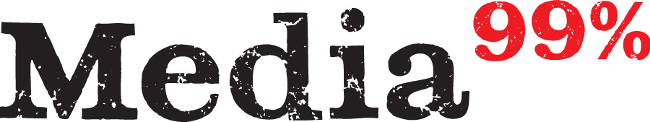

Welcome to the Media for the 99 Percent Logo!

