
July 22, 2013

Thank you so much for thinking of the Inn of Chicago – Magnificent Mile!

For over to 80 years we have been a sought after destination in Chicago’s historical Downtown Area. Located in the heart of Chicago’s world-famous “Magnificent Mile” we are steps from the city’s biggest attractions like Water Tower Place, Navy Pier, and a host of the best shopping, restaurants, and entertainment.

Boasting 359 guestrooms, we are well appointed to suit the needs of all. In your room you will discover a varied selection of in room movies to order, free local phone calls with no access fees, a coffee maker, hairdryer, iron & ironing board as well as our latest addition of Internet access. Our guests may also take advantage of our lobby bar, The INN BAR, complimentary fitness center, wireless Internet access in the lobby, and breathtaking views from our Skyline Terrace located on the 22nd Floor.

We appreciate the opportunity to earn your business and truly look forward to partnering with you to make your event a success. Thank you for taking the time to review this proposal.

Sleeping Room Rates:
Dates: | February 5 – 9, 2014
Rates: | $89 Single / Double
Tax: | 16.4%

Meeting Space:
Dimensions |  |  |  | Seating Capacity
Meeting Room | Size | Sq. Ft. | Ceiling | Theatre | Classroom | Conference | U-Shape | Hollow Square | Banquet | Reception
Buckingham | 41 x 47 | 1927 | 8’ | 150 | 120 | 40 | 40 | 40 | 150 | 175
Harbor | 31 x 21 | 651 | 8’ | 60 | 36 | 25 | 25 | 24 | 50 | 60
Windy City | 32 x 17 | 544 | 8’ | 50 | 36 | 25 | 25 | 24 | 50 | 60
St. Clair | 38 x 15 | 570 | 8’ | 40 | 15 | 30 | -- | 26 | 40 | 50
Michigan | 44 x 16 | 725 | 8’ | 70 | 35 | 34 | 24 | 28 | 70 | 60
Boardroom | 30 x 21 | 500 | 8’ | -- | -- | 12 | -- | -- | -- | --
SkyDeck | South - 59 x16  West - 48 x 18 | 1520 | Open | -- | -- | -- | -- | -- | -- | 100

Schedule of Events: SUGGESTIONS BASED ON YOUR SPECS
Dates | Time | Function | # / Setup | Food & Beverage | Cost
Feb. 6 – 9, 2014 | 7AM – 8AM | Breakfast | 120 Theater | Fresh Muffins, & Pastries and Whole Fruit. Served w/ Butter & Preserves
 | 8AM – 5PM | Meeting | 120 Theater | Food buffets will be setup out side the room | $300 plus 4.5% Tax
 | 8AM – 5PM | Breakout | 40 Theater | Water Service
 | 8AM – 5PM | Breakout | 40 Theater | Water Service
 | 10AM – 1030AM | AM Break | 120 Theater | Assorted Bottled Water & Sodas
 | 12PM – 1PM | Lunch | 120 Theater | On their own for Lunch? | Meeting Planner Package -
 | 230PM – 3PM | PM Break | 120 Theater | Assorted Cookies, Brownies, & Sodas | $30pp plus 10.5% tax & 24% Service Fee
 |  |  |  |  | TOTAL - $5,155.50 per day

Meeting LCD Projector Package: LCD Projector, Tripod Screen, Stand/cart, VGA, Cable, Power $ 700.00 per day - $2800.00
Tax: 9%
Service Fee: 24%
Labor Set up: $60
Labor Tear Down: $60
Event Consumables: $25
TOTAL: $3,869

EVENT TOTAL - $5,155.50 + $5,155.50 + $5,155.50 + $5,155.50 + $3,869.00 = $24,491

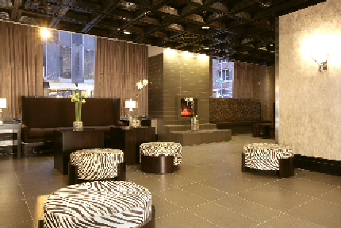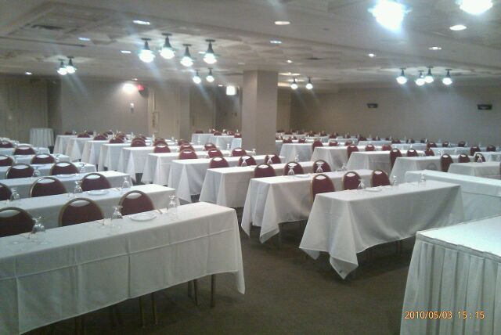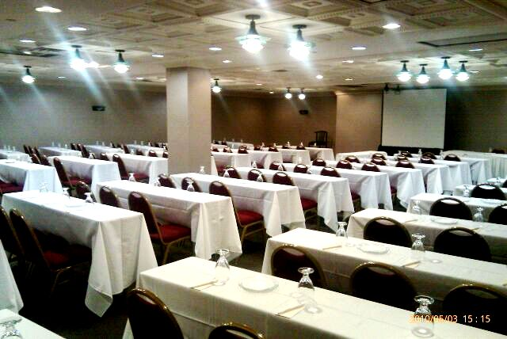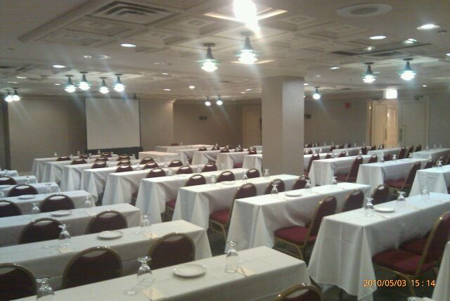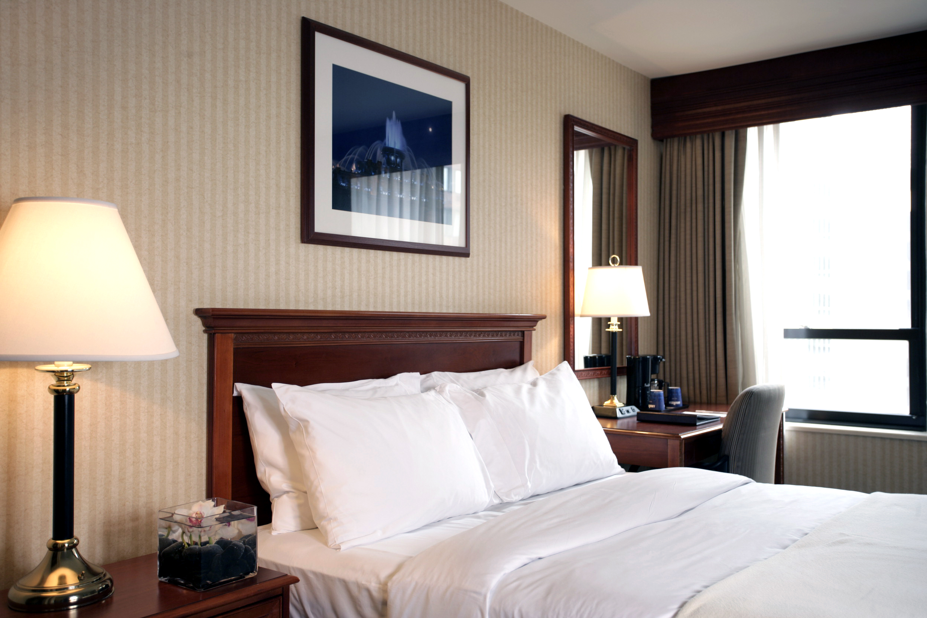

The Buckingham & Michigan Room, as well as the Boardroom, have a rental of $1200.
The Harbor, Windy City, & St. Clair Rooms have a rental of $800.
All rooms are subject to a Set-up/Tear down fee of $200
***Food and Beverage minimums are based on your number of attendees multiplied by the per person cost of meals.
***Food and Beverage costs are not inclusive of tax, gratuity, service charges and or room rental when applicable.
***Food and Beverage menu choices are taken into strong consideration when determining room rental discounts

Thank you in advance for your consideration. I would certainly like to put together a formal agreement at your request. Currently we are not holding space for your group, but it would be our pleasure to do so. Details outlined in this proposal are available until August 9, 2013.

I look forward to working with you and if you have any questions, I can be reached directly at 312-573-3152.

Best Regards!

Marques D. Austin
Inn of Chicago – Magnificent Mile
162 E Ohio Street * Chicago, Illinois 60611
Phone: 312.573.3152 * Fax: 312.573.3140
marques.austin@innofchicago.com
www.innofchicago.com

