

Contact: Erin Polgreen
Erin@themediaconsortium.com
312.841.0553
www.themediaconsortium.org

Inform and Engage your Audiences
How can you convey latest news, opinion and information about critical issues to your constituency? The Media Consortium has created a social media toolkit—free blogs, headline feeds and widgets—to help connect your audience to news and information about the issues they care about most.
The MediaWires project showcases first-rate independent journalism produced by members of The Media Consortium. So how does it work?
These tools provide valuable context for critical political issues like immigration, the economy, sustainability and healthcare. In our emerging media ecosystem, audiences value curatorial content that puts valuable information at their fingertips—here’s how you can be their go-to source.
The Media Consortium currently sponsors four hub sites that archives content related to an issue:

- The Audit: Economy
- The Pulse: Health Care
- The Diaspora: Immigration
- The Mulch: Environment

Think of these as one-stop shops for all the best in independent reporting from Media Consortium members.
How you can participate:
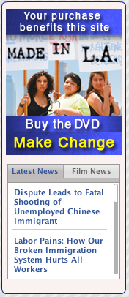
1.) Publish the blogs! Our bloggers contextualize the best independent reporting for weekly posts on Immigration, Health care, the Environment and the Economy. Every Tuesday, Wednesday, Thursday and Friday, we email free, open-source news roundups of content from the ladders. Your organization is welcome to repost any blog, at any time. Contact erin@themediaconsortium.com to join the blog email list. To learn more about our bloggers, visit: http://is.gd/t1DC.

2.) Post a widget. Hosting up-to-date headlines from the best independent media on your website is simple: Install one of our TMC widgets (customized sample on the right). You can place the widgets as an informational resource for your audience on your home page, in an article, or in advertising space. Our widgets are available in three different sizes for the following topics: economy, healthcare, immigration, sustain, and a feed of all content from Media Consortium members.
These widgets can be dropped at the bottom of an article or incorporated into a sidebar on your organization's website. For instructions and coding, visit: http://is.gd/kQzZ. We can also customize a widget for you! Let us know if you'd like to use a widget to help get the word our about a campaign or action and we can help you design and distribute the final product.

3.) Host XML/RSS Headline feeds: RSS feeds a offer a timely list of headlines that link directly to your content. If you'd like to customize a feed for your site, contact erin@themediaconsortium.com.

