Q&A’s for audience
- How many here are students?
- how many here are alumnis? Journalism is your current career?
- How many here consider themselves primarily print reporters? Online only? Radio? Television? (would say that now and in the future-never consider yourself a reporter for only one platform?)
- How many people blog? Have created videos for youtube (fun or for work)?
- How many use twitter or facebook to help with your reporting? To engage and have conversations with your audience?
- How many are scared about their future in journalism? Excited? Both?

WHAT IS THE MEDIA CONSORTIUM?

In fall 2009, The Media Consortium completed a year-long study called The Big Thaw: that was born out of a desire to change the game for media consortium members and help us become the shapers of tomorrow’s media landscape.

GIVE SHORT OVERVIEW OF THE BIG THAW: CHARTING A NEW COURSE FOR JOURNALISM –50,000 FOOT POV AND THEN COME BACK DOWN TO EARTH TO TALK ABOUT EXACTLY WHAT WE’RE DOING

AND HAPPY TO GIVE MORE DETAILS AND WHAT WE’VE DONE BC OF THE RECOMMENDATOINS WITHIN THE REPORT—THAT’S THE FUN STUFF.

As traditional business and editorial models melt away, new innovations are rapidly reforming journalism. The question we asked is:

Can media producers adapt and lead, or will they disappear as we move out of journalism’s Ice Age?

In The Big Thaw, we lay out four interlocked areas that we as journalism producers must navigate as we look to identify how to strategically evolve in this new environment. HAPPY TO GET MORE IN DEPTH OR ANSWER ANY QUESTIONS ABOUT THE FOLLOWING.
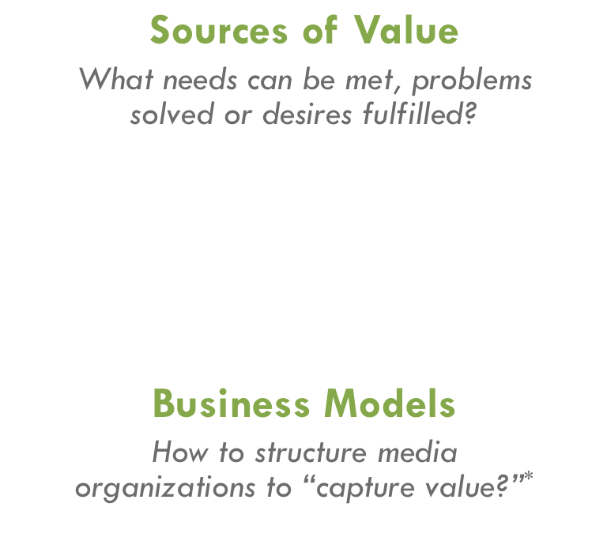

The Big Thaw had 4 major recommendations:

Launch of II Labs: EXPLAIN THE INCUBATION AND INNOVATION LABS
Research, collaboration, talking to experts, seed money

Small group labs
Within the Digital Innovation Studio, The Media Consortium has recruited over a dozen media organizations to participate in one or more of the following labs.
- Moving into mobile: Cell phones, e-readers, and iPads, oh my!
- Integrating journalism with community engagement and building models
- Experimenting with new revenue-generating opportunities

With these small-group labs, The Media Consortium's goals are to support deep learning and incremental shifts for TMC members to develop new models for revenue generation, audience development, and editorial content. Cumulatively, these labs will catalyze a broad shift in how independent media outlets survive and thrive in a 21st century landscape. In addition to organizing the labs, The Media Consortium is providing seed money to help incubate a collaborative experiment for each lab.

Explain Hackathon

LEAN AND MEAN

MULTIPLE SKILS:
MOZILLA, OPEN JOURNALISM COURSE

JOURNALISM, HACKERS, NEW MEDIA, BIZ, MARKETING

DON’T EXPECT TO WORK IN ONE PLACE FOR THE REST OF YOUR LIVE

