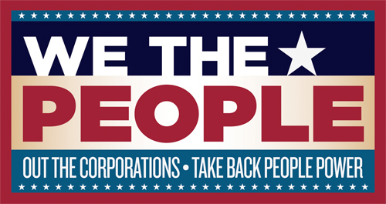

Outing the Corporations Editorial Collaboration
Memorandum of Understanding
July 25, 2011

Outing the Corporations Project Overview
We the People is partnering with The Media Consortium to support special investigative coverage that tracks corporate influence on American politics. Reporting will be produced between September 19 and November 2, at the one-year mark ahead of the 2012 election. Throughout the development and production process, We The People will work with TMC members and allies to create a “media crescendo” moment—a moment when the stories produced by TMC members and the issue of corporate influence itself become a hot topic across all media—that can be used by advocacy groups and the netroots to create social action. In addition, We The People will feature TMC members’ stories as part of the high-profile live event it is planning for late fall.

Both TMC and WTP have a vital interest in reporting on corporate funding of elections in the wake of the Citizens United decision by the U.S. Supreme Court. The aim of this project is to facilitate such reporting and to increase its impact by a) contracting with a number of TMC members to produce such reports, b) managing the project such that all reports will appear within a limited period no longer than four weeks, and c) using a number of publicity vehicles including but not limited to social media to ensure the reports make a direct impact on the public.

I. Participants:
- The Media Consortium, hereinafter “TMC”
- “We the People,” a project by Jay Harris, hereinafter “WTP”
- _______________(Organization name here), hearinafter “participating TMC member outlet”
II. Responsibilities
Participating TMC member outlet will:
- Produce _____ pieces of content for publication during Sept. 19-Nov. 2, 2011. Fill in any additional details regarding content here:
- Make sure that reporters and editors participating in this collaboration are available for calls to review program components and draft promotional strategies.
- Keep TMC and WTP staff apprised of any changes in final product output before publication.
- Promote all reporting from your organization on your social networks (Twitter, Facebook, etc.). You will also send out press releases, e-newsletters and participate in any other promotional efforts as needed.
- Work with WTP and TMC in advance of publication to support story promotion and booking of your reporter(s) on other media. This includes sharing story planning/development on a regular basis with key WTP and TMC representatives and providing information for an editorial calendar that will be shared with WTP and TMC staff representatives and any publicity contractors.
- Credit The Media Consortium and We The People for supporting the reporting. Exact language TBD.
- Allow We The People to post, link and/or reprint produced pieces for online and/or print toolkits.

TMC and WTP will:
- Provide _______ (fill in amount) in financial support for this work, which will be distributed once a signed MOU has been returned to TMC staff.
- Organize strategy calls and documents to keep participating TMC member outlets informed regarding program developments.
- Work with participating TMC member outlets in advance of publication to support story promotion and booking of reporter(s) on other media.
- Work in concert to distribute and raise visibility of work generated by participating TMC member outlets. Promote reporting from participating TMC member outlets on our social networks (Twitter, Facebook, etc.).

III. Purpose
TMC, WTP and participating TMC member outlet enter this MOU to affirm their collaboration and to clarify their roles and expectations with regards to this project. If participating TMC member outlet does not or can not fulfill the terms of this agreement, TMC reserves the right to demand repayment of funds dispersed under this agreement.

VIII. Concurrence

________________________________________ _________________________
TMC Representative Date

________________________________________ _________________________
TMC Member Outlet Representative Date

