

July 16, 2009
NAME
ADDRESS
CITY STATE ZIP
Re: The Media Consortium Independent Media Internship
Dear XXX:
Thank you for agreeing to participate in The Media Consortium's Independent Media Internship program. I expect this to be a successful program for you, the intern, and The Media Consortium.
As part of this program, you have previously agreed to certain terms when you applied to participate. By signing and returning this letter, you agree to the following terms in exchange for participating in the Independent Media Internship and the benefits therefrom:
- You agree to organize at least one special editorial project for the intern to perform during his or her tenure;
- You agree to set up regular weekly editorial duties for the intern. You agree that these duties will represent actual editorial duties of a professional nature and will not be limited to the duties of an assistant, e.g. fetching coffee;
- You agree to meet with the intern for regular mentoring sessions every two weeks;

- You agree to contact The Media Consortium immediately if you have any issue's relating to the intern's performance, behavior, or attendance;
- You agree to provide an appropriate travel stipend for interns that covers there daily costs traveling to and from work, and;
- You agree to complete a final report to The Media Consortium at the end of the intern’s tenure detailing the performance of the intern and your thoughts on the program along with suggestions for making it more successful.

By signing and returning this agreement you also certify that you have paid your dues to The Media Consortium for 2009 and are otherwise a current member in good standing.
I, ___________________, having read the foregoing, agree to all the terms contained therein. I further represent that I am a lawful agent of OUTLET NAME and am authorized to enter into legal agreements on its behalf.
The Media Consortium reserves the right to terminate this program immediately if at any point you do not adhere to the terms as stated above.
_______________________________ ____________________
Name: XXXX Date:
Thank you for your participation in what I am sure will be a successful program. Please return this by email to elogan@motherjones.com, or fax them to her direct line at: 415.321.4900 no later than Jan 25, 2010.
Very truly yours,
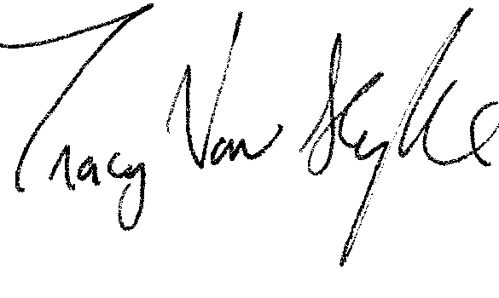
______________________
Tracy Van Slyke,
Project Director, The Media Consortium

