

July 28, 2009
NAME
ADDRESS
CITY STATE ZIP
Re: Internship Agreement
Dear XXX:
Congratulations on your selection as a Media Consortium intern. You were selected upon careful review of many applicants, and we, and our members, look forward to working with you over the term of your internship.
This letter confirms and constitutes our offer of a three-month internship to you. Your signature and the return of this letter to us shall constitute your acceptance of this offer.
If you accept this offer, the Media Consortium will place you with OUTLET NAME, one of its member organizations. While you will be under the supervision of OUTLET NAME, this offer is from The Media Consortium, and this agreement is solely between you and The Media Consortium.
If you accept this offer, The Media Consortium agrees to pay you a (taxable) stipend of $2,000. Your 12-week $2,000 stipend is agreed to be paid in semi-monthly installments-on the fifteenth (15) and the last day of the month.
By accepting this offer, you agree to a number of obligations. First, you agree to work for OUTLET NAME for 32 hours a week for 12 weeks starting on Feb 1, 2010 (unless The Media Consortium has previously agreed to a different start date). You will be overseen and directed by OUTLET NAME and during this time, you will perform the following duties:
- Participate in at least one special editorial project developed by the media outlet
- Conduct weekly editorial duties including fact-checking, writing, editing, etc.
- Participate in monthly Media Consortium-organized networking and professional development conference calls
- Provide a short narrative describing and commenting on your work to The Media Consortium at the fourth and eighth weeks of the program, and a final report upon completion of the internship.
You will also be allowed reasonable personal leave in accord with the standard policies of OUTLET NAME. You further agree that you will contact your direct supervisor at OUTLET NAME with any questions or concerns as to your duties under the internship program. You agree that if your questions or concerns remain after meeting with your direct supervisor you will immediately contact The Media Consortium.
You further agree and understand that if your direct supervisor determines, in his or her sole discretion, that your work performance is unsatisfactory or that you have excessive unexcused absences, The Media Consortium may rescind the internship and avoid any payments not made at the time of the rescission.

This offer shall remain open until Jan 25, 2010.
If you agree to all these terms, please sign below and return this agreement to: Emma Logan via email at elogan@motherjones.com, or fax them to her direct line at: 415.321.4900.
___________________________ ____________________
Name: XXXX Date:
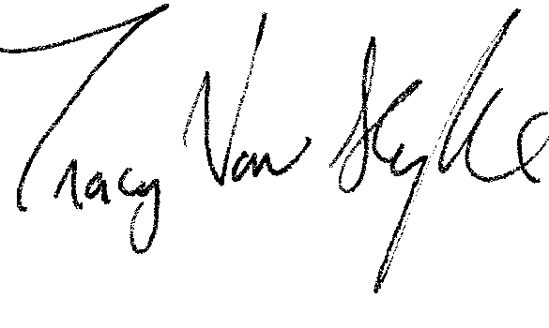
Again, we are excited by your expected participation in this program and look forward to working with you!
Very truly yours,
_______________________
Tracy Van Slyke
Project Director, The Media Consortium

