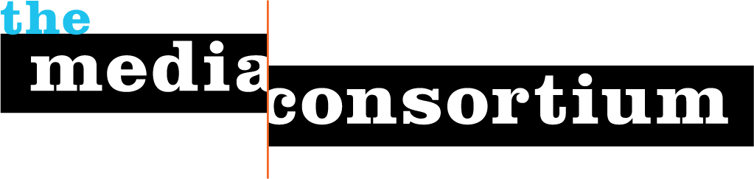
Meeting Notes, Feb 10-11
Washington, DC
This one-sheet offers a brief outline of next steps and feedback from the meeting itself. More detailed notes are being compiled and a final version will be released shortly.
Projects/Next Steps
MC staff is working to make the following four items available to members in the coming weeks. These ideas were generated by MC members as a means to inform and engage around projects and initiatives.
- Audio for Chris Hughes
- Webinar on GameChangers
- Make all meeting materials available online
- Online salons/conference calls with industry leaders to inform members on trends and technologies
Project development teams: The following people signed up to assist with the development of beta programs for the Progressive Media Internships and Media Darlings project. Please contact erin@themediaconsortium.com if you would like to be included in this process.
Prog. Media Internships: Team will develop criteria (for participating outlets and potential interns) and program for beta run of internships, in which 12 interns will be placed among MC member outlets for 3-4 months in 2009.
- Ida Wahlstrom
- Chris Rabb
- Linda Jue
- Andrew Golis (advisory capacity)
- Josh Stearns (advisory capacity)
Media Darlings: Team will help brainstorm partners to promote media darlings, narrow down issue focus for media darlings beta program, work with MC staff to identify 4-6 journalists with issue expertise to become our “test cases” (with an emphasis on diversity).
- Chris Rabb
- Esther Kaplan
- Julie Bergman-Sender
- Noel Rabinowitz
MediaWire Suggestions
MC members brainstormed the following ideas for our 5th MediaWire. More information on this project will be available on Friday, February 20.
- Race
- National Security
- Arts
- Afghanistan
- Sustainable Agriculture
Day One Feedback:
Plusses:
- Location
- Pre-meeting communication
- Phenomenal organization by MC staff
- Good reintroduction to MC programs
- Marketplace was excellent, would have loved some Q&A time
- Chris Hughes was very informational
Deltas:
- Closer to public transportation
- Move marketplace to AM session/create marketplace breakout sessions
- 2 big ppt presentations in the 1st day was a lot of sitting/watching
- more time with Chris Hughes and Rep. Grijalva would have been good
- Definition of Progressive for Obama Era
- Name badges would be helpful
Day Two Feedback:
Plusses:
- Loved initial feedback from gamechangers
- Wonderful to see that the MC is making actual progress.
- MC staff is working with members to move projects forward
- There is a great willingness to collaborate across all sectors/media types
- Wonderful to have opportunity to gather
Deltas:
- Would have liked to see GameChangers earlier
  - Follow up discussion would be helpful
- Would like better evaluation process
- More talk about political necessity of MC
- More CC leadership
- Move potential projects to beginning of meeting to help frame oncoming presentations
- Make room to develop more projects

