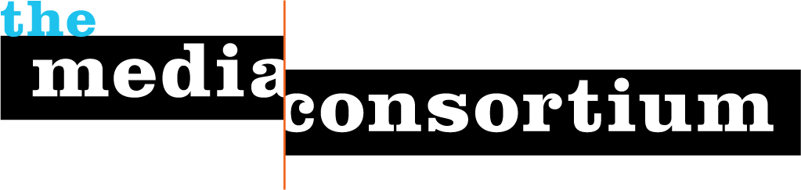
Submitted by The Media Consortium, a project of the Foundation for National Progress
Date: June 21. 2011
To: The Atlantic Philanthropies

The Media Consortium Internship Program: Building a Future of Lasting Change

Today’s youth will play a critical role in the development of new policies and government infrastructure. They will also communicate their ideals using new technologies and engage new communities in the democratic process—but only if we invest in them. The Media Consortium, a national network of 50 leading independent media outlets, seeks $100,000 from Atlantic Philanthropies to fund a media internship program that will build a strong, diverse network of independent media leaders that are committed to social justice and lasting change.

Program Overview
Most media internships are unpaid and offer little support to young journalists, particularly those interested in using media to further social change. This program ensures that engaged young journalists have the financial support and mentorship necessary to build their careers. A dedicated Media Consortium staffer will create monthly professional development calls for interns, and ensure that interns are meeting regularly with their mentors and are supported in their work. Member organizations pay part of the cost of the interns, giving them an incentive to get the most out of the relationship.

The Independent Media Internship program is, in many ways, a natural outgrowth of The Media Consortium’s core mission and vision: Not only does is allow us to shore up and support our members, but is a necessary investment in the future of journalism that informs and shapes a vital democracy.

The Media Internship Program will recruit ten ethnically diverse, politically active, civically engaged undergraduate and graduate students who already have significant school-based experience in journalism and pair them with a Media Consortium member organization. This program is designed to build concrete skills and connections in the media landscape—our interns will not be getting coffee. , Interns will get hands-on training in real-world journalism by supporting the work of their placement organization through fact-checking, research, writing and multimedia production. Interns will be paid $1000/month over a period of 3-4 months to develop and complete at least two significant editorial projects at their host organization. In addition, they will be paired with staff mentors at their host organization. These mentors will meet with interns on a regular basis to discuss their work and career path.

This program will have a domino-style impact: One young journalist who has the connections and drive to tell a story well has the power to inform and engage thousands of individuals. By engaging passionate voices at an early age and providing them with a tool kit for success, The Media Consortium is fostering a generation of media leaders committed to telling key stories, asking hard questions and inciting debate around vital issues.

A Strong Track Record
The Media Consortium is the ideal organization to incubate and launch a lasting internship program. In 2009-2010, we tested this program, placing over 12 interns with member organizations over three four-month periods. The pilot program was a significant success—interns produced substantial, civically-engaged journalism, including a citizen reporting project tracking the Tea Party, a blog on the role of Twitter in the Iranian election protests that made the front page of the Huffington Post, and a groundbreaking report by intern Cindy Von Quednow on the impact of the recession on ethnic media—an article which garnered the 4th highest pageviews of all time for Colorlines.com.

We are excited to build on the success of this pilot with support of Atlantic Philanthropies. By engaging the passionate voices of aspiring journalists and providing them with a toolkit for success, The Media Consortium’s Internship Program can foster the next generation of media leaders.

Who We Are
Founded in 2005, The Media Consortium is a national network of 50 leading independent journalism organizations that work in print, online, on television and on the radio. We support smart, powerful and passionate journalism that redefines the political and cultural conversations in America. Our current members include:

Afronetizen
AlterNet
American Forum
The American Independent News Network
The American Prospect
Berrett-Koehler Publishers
Brave New Films
Campus Progress
Care2
Change.org
Chelsea Green
The Chicago Reporter
Colorlines
Democracy Now!
Earth Island Journal
Feet in 2 Worlds
Feministing
Free Speech Radio News
FreeSpeechTV
GlobalVision
GRITtv
Grist
The G.W. Williams Center for Independent Journalism
Inter Press Service
In These Times
LinkTV
Media Venture Collective
Mother Jones
Ms. Magazine
NAMAC
The Nation
The Nation Institure
National Radio Project
New America Media
The New Press
Oakland Local
Orion
The Progressive
Public News Service
The Real News Network
RH Reality Check
The Texas Observer
Truthout
The UpTake
Washington Monthly
Western Citizen
The Women’s Media Center
Workers’ Independent News
Yes! Magazine
The Young Turks

